Service Description
Fixed Data

Document Control
Status | Drafted for digital.nsw.gov.au
Author’s Name  Position | Matt Duniam  Network Architect
Category (Sub-Category) | ICT (Telecommunications)
Summary | Service Description for Fixed Data under the Telecommunications Purchasing Arrangements

Revision record
Please note significant document changes with a version increment of 1.0. Minor administrative changes, where the meaning or intention of the document is not altered should increase by an increment of 0.1.
Version | Date | Author | Summary of changes
1.0 | 19/12/2017 | Matt Duniam | Original set of services.  Released as part of RFx101331
2.0 | 02/06/2019 | Matt Duniam | Updated to include details of more granular parameters.  Released as part of RFx133881
2.1 | 06/04/2020 | Matt Duniam | Minor update for digital.nsw.gov.au

Copyright
This work is licensed under the Creative Commons Attribution-NoDerivatives 4.0 International License. Terms for use can be found at https://www.customerservice.nsw.gov.au/copyright and the applicable license for use is at http://creativecommons.org/licenses/by-nd/4.0/.
© State of New South Wales through Department of Customer Service, 2020.

Table of Contents

Document Control 2

1. Service Tower Description 4

2. Service Category – Point-to-Point Connectivity 5
2.1 Passive Point-to-Point Connectivity 5
2.2 Active Point-to-Point Connectivity 6

3. Service Category – Private Fixed WAN Connections 8
3.1 Managed L3VPN 8
3.2 Low-Cost Managed L3VPN 9
3.3 Unmanaged L2/L3VPN 11

4. Glossary 13

Service Tower Description
Fixed Data Services provide a private network connection for customer fixed sites to enable communication between sites and the customer data centres. The delivery mechanism can be via fixed or wireless technology.
These services are expected to evolve as technology changes and the security and bandwidth demands related to fixed data connectivity escalate, driven primarily by the continual move to public Cloud and adoption of the Government’s Digital Strategy.
It is expected that individual services may be consumed from different Suppliers, and that services will be delivered in a modular fashion to facilitate that.
The services within this catalogue must meet the requirements for Fixed Data Services defined in the Requirements Schedule and comply with the Common Services Catalogue.
This catalogue defines the minimum set of base services required by the customers and provides a generalised overview of their current states.

Service Category – Point-to-Point Connectivity

Passive Point-to-Point Connectivity
Service Overview | This Service is where passive connectivity is required between two locations, and the Eligible Customer requires the unmanaged circuit to be terminated on their equipment (or equipment provided by a third party). An example of this service is a Layer 1 dark (unlit) fibre.  As the Service is unmanaged it will be up to the Eligible Customer to determine if there are availability or performance issues, and to report these to the Supplier for resolution.  This Service provides connectivity between two locations as per Figure 1 below.  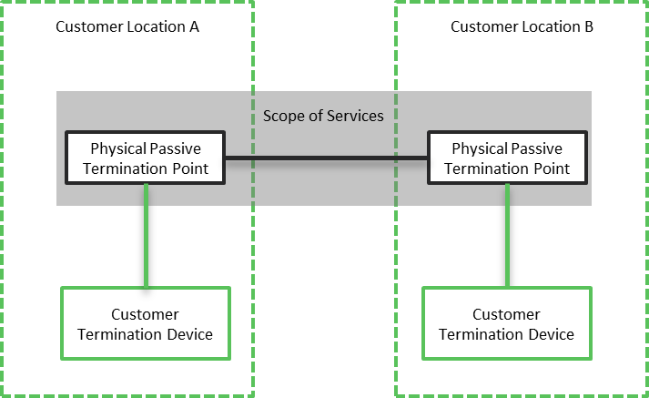  Figure 1: Point to Point demarcation and scope  The Service must provide all components within the scope area highlighted and provide Common Services as per the Common Services schedule.
Service Deliverables | The Base Service will provide:  - Connectivity between two sites, which could be Eligible Customer or third-party locations.  - A standards-based termination at each site to connect to Eligible Customer equipment.  - Support for standards-based optics e.g. 1000BASE-LX/LH, 1000BASE-EX, 1000BASE-ZX  - The Service should support optics that provide a range of bandwidths of up to 100Gbps, dependant on the distance between sites and the optics deployed by the Eligible Customer.  - Reactive management of the Service and interconnection points.  Service Options that Eligible Customers are interested in, and could also be provided are:  - A secondary service that is diverse to the primary service, so that the Eligible Customer can deploy the site with High Availability. This service may have Service Level’s that differ from the primary service.  - Support for optics that provide speeds higher than 100Gbps.

Active Point-to-Point Connectivity
Service Overview | Active Point-to-Point connectivity is where connectivity is required between two locations, and the Eligible Customer requires the Supplier to:  - Monitor and proactively manage availability, capacity, and performance.  - Provide an active termination point.  Examples of this type of service are coloured wavelength and Fibre channel.  This Service provides connectivity between two locations as per Figure 2 below.  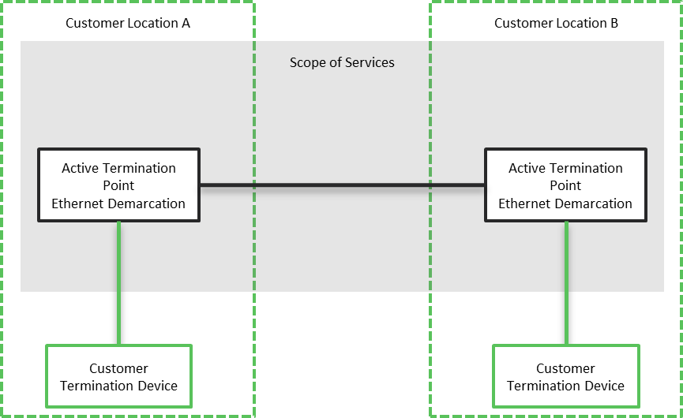  Figure 2: Point to Point demarcation and scope  The Service must provide all components within the scope area highlighted and provide Common Services as per the Common Services schedule.
Service Deliverables | The Base Service will provide:  - Connectivity between two sites, which could be Eligible Customer or third-party locations.  - Connectivity at layer 1.  - Full proactive management of the Service, including monitoring and pro-active response for capacity, availability, and performance.  - A standards-based termination at each site to connect to Eligible Customer equipment.  - The Service should support a range of bandwidths between 1Gbps and 100Gbps.  Service Options that Eligible Customers are interested in, and could also be provided are:  - A secondary service that is diverse to the primary service, so that the Eligible Customer can deploy the site with High Availability. This service may have Service Level’s that differ from the primary service.  - Support for speeds higher than 100Gbps.  - Provide optical delivery to the Eligible Customer termination equipment, for example to support Fibre Channel  - Support for Multi-point connectivity and topologies, where more than one Service is procured.

Service Category – Private Fixed WAN Connections

Managed L3VPN
Service Overview | The Managed L3VPN service is where there are two or more sites that need to connect to the same Private Network, and where the Eligible Customer requires the Supplier to:  - Monitor and proactively manage availability, capacity, and performance.  - Provide the CPE for the site, allowing the Eligible Customer LAN to connect directly.  - Provide connectivity from the site to a Private Network.  - Provide connectivity from the Private Network to the Government Data Centres by default.  This Service provides connectivity to a site as per Figure 3 below. For illustration purposes only one Eligible Customer site is shown, however there could be many. The Data Centre Demarcation is shared for all sites.  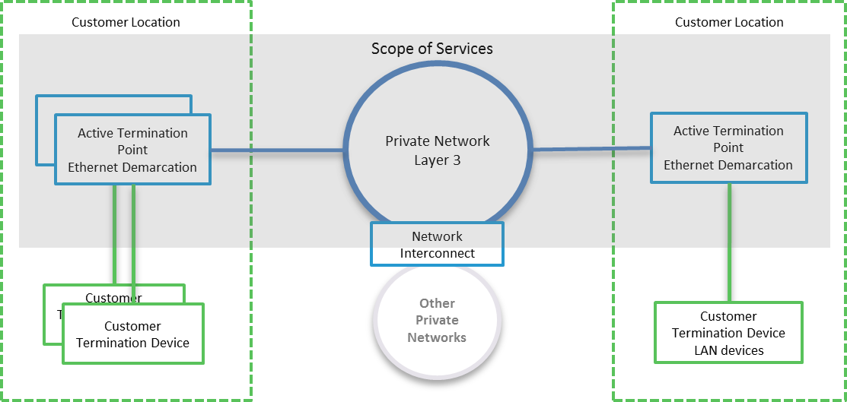  Figure 3: Managed Private Fixed Connection with CPE  The Service must provide all components within the scope area highlighted and provide Common Services as per the Common Services schedule.  Services will be differentiated by the access network that is used, in terms of:  - Type; head-end, tail  - Physical layer; satellite, fixed wireless, copper, fibre  - Provider; respondents, NBN, 3rd party  - NBN Traffic Class; TC4, TC2, Enterprise Ethernet
Service Deliverables | The Base Service will provide:  - A Private Layer 3 network that supports Quality of Service.  - Support for up to 6 service classes. Each with its own set of performance criteria relating to bandwidth contention, latency, jitter and packet loss.  - Connectivity to an Eligible Customer site, which could be an Eligible Customer or third-party location.  - Guaranteed symmetrical bandwidth.  - A range of Eligible Customer selectable bandwidths.  - Full proactive management of the Service, including monitoring and pro-active response for capacity, availability, security and performance.  - A CPE with a standards-based termination to interconnect with Eligible Customer equipment.  Service Options that Eligible Customers are interested in, and could also be provided are:  - Internet offload i.e. the ability to send Internet destined traffic to the Internet directly from the site.  - Circuit aggregation and load balancing, i.e. the ability to connect additional circuits (with potentially different circuit technology from a range of Suppliers) and utilise the additional circuits based on a range of factors, such as the traffic type.  - A Private Network interconnection, allowing routed connectivity to other trusted networks.

Low-Cost Managed L3VPN
Service Overview | The Low-Cost Managed L3VPN service is where a site requires a private connection and Internet access provides the required attributes. The Eligible Customer requires the Supplier to:  - Monitor and proactively manage availability, capacity, and performance.  - Provide the CPE for the site, allowing the Eligible Customer LAN to connect directly.  - Provide connectivity from the site to the Internet.  - Provide a Private Network over the Internet, that sites and the Data Centres connect to secure traffic.  This Service provides connectivity to a site as per Figure 44 below. For illustration purposes only one Eligible Customer site is shown, however, there could be many. The Data Centre Demarcation is shared for all sites.  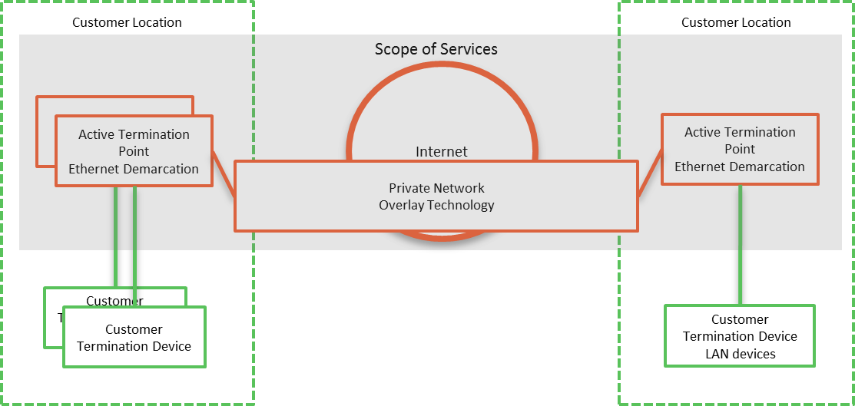  Figure 4: Internet VPN with Site CPE  The Service must provide all components within the scope area highlighted and provide Common Services as per the Common Services schedule.  Services will be differentiated by the access network that is used, in terms of:  - Type; head-end, tail  - Physical layer; satellite, fixed wireless, copper, fibre  - Provider; respondents, NBN, 3rd party  - NBN Traffic Class; TC4, TC2, Enterprise Ethernet
Service Deliverables | The Base Service will provide:  - A Private Network that runs over the Internet.  - A Private secure tunnel from the site to the Virtual Private Network.  - Internet connectivity to an Eligible Customer site  - Through the capabilities of the overlay; hub-and-spoke or mesh topologies  - Best efforts bandwidth. The Service should provide a range of Eligible Customer selectable bandwidths and contention ratios.  - Full proactive management of the Service, including monitoring and pro-active response for capacity, availability, security and performance.  - A standards-based Ethernet termination at each site to connect to Eligible Customer equipment.  Service Options that Eligible Customers are interested in, and could also be provided are:  - Internet offload, i.e. the ability to send Internet destined traffic to the Internet directly from the site.  - Circuit aggregation and load balancing, i.e. the ability to connect additional circuits (potentially with different circuit technology from a range of Suppliers) and utilise the additional circuits based on a range of factors, such as the traffic type.  - Traffic engineering, or other methods to improve performance.

Unmanaged L2/L3VPN
Service Overview | The Unmanaged L2/L3VPN service is where there are many sites that need to connect to the same Private Network, and where the Eligible Customer requires the Supplier to:  - Monitor and proactively manage availability.  - Provide connectivity from the site to a Private Network.  - Provide connectivity from the Private Network to the Government Data Centres by default.  The Eligible Customer will provide a CPE to connect to the Service at a site.  This Service provides connectivity to a site as per Figure 5 below. For illustration purposes only one Eligible Customer site is shown, however there could be many. The Data Centre Demarcation is shared for all sites.  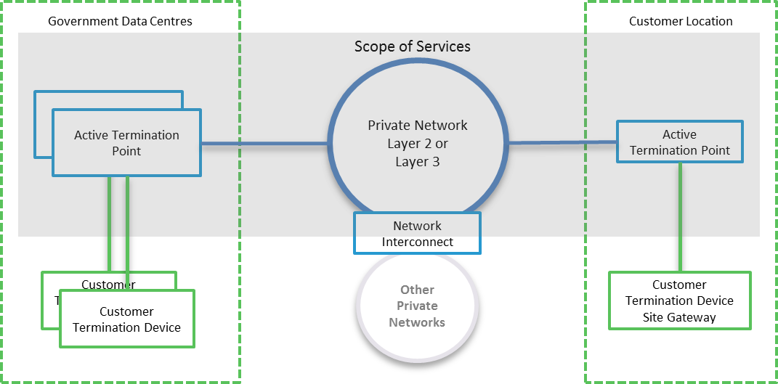  Figure 5: Managed Private Fixed Connection without CPE  The Service must provide all components within the scope area highlighted and provide Common Services as per the Common Services schedule.  Services will be differentiated by the access network that is used, in terms of:  - Type; head-end, tail  - Physical layer; satellite, fixed wireless, copper, fibre  - Provider; respondents, NBN, 3rd party  - NBN Traffic Class; TC4, TC2, Enterprise Ethernet
Service Deliverables | The Base Service will provide:  - A Private Layer 2 or 3 network that supports Quality of Service.  - A range of Eligible Customer selectable bandwidths.  - Support for up to 6 service classes. Each with its own set of performance criteria relating to bandwidth contention, latency, jitter and packet loss.  - Connectivity to an Eligible Customer site, which could be an Eligible Customer or third-party location.  - Guaranteed symmetrical bandwidth.  - Full proactive management of the Service, including monitoring and pro-active response for availability.  - A standards-based termination at each site to connect to Eligible Customer equipment.  Service Options that Eligible Customers are interested in, and could also be provided are:  - High Availability assurance, where, on a regular basis, the paths are audited, and failover is tested.  - Asymmetric bandwidth  - Quality of Service for the Service to the site.  - A secondary service that is diverse to the primary service, so that the Eligible Customer can deploy the site with High Availability. This service may have Service Level’s that differ from the primary service.

Glossary
Term or short form | Long-form | Definition
aaS | as-a-Service | An item, or grouping of items, made available to a customer as a service
Active Termination |  | Where the Service Provider provide a device that terminates the service at a site and enables end-to-end management.
ADSL | Asymmetric Digital Subscriber Line
APN | Access Point Name | A gateway between a mobile network and another network, such as the Internet or a Private WAN.
bps or bit/s | Bits per second
BYO | Bring your own
CAB | Change Advisory Board
Circuit |  | For data connections, a circuit a path that data transverses between two points. A circuit is a component of a Service.
CMS | Configuration Management System
Contract Authority |  | The central entity that is accountable and responsible for the Head Agreements of the TPAs
CoS | Class of Service
 |  | TPA Release Version
CSI | Continual Service Improvement
Customer |  | NSW Government Agency, or any organisation procuring services from the Service Catalogues.
CPE | Customer Premise Equipment | A device that is used by Service Providers to terminate services at a site.
Customer Termination Device |  | A Customer device that is connected to the Provider's equipment
DHCP | Dynamic Host Control Protocol
DISS | Digital Information Security Strategy
DoS (or DDoS) | Denial of service (or distributed denial of service) | An attack that attempts to make a service unavailable by overwhelming it with traffic from multiple sources.
DWDM | Dense Wavelength Division Multiplexing
Error |  | A design flaw or malfunction that causes a failure of one or more IT services or other configuration items.
Event |  | A change of state that has significance for the management of a service.
Gateway device |  | A layer 3 device at a site that acts as the site’s router, to transmit packets to the WAN. Host devices have a gateway device configured, typically via DHCP.
Gbps or Gbit/s | Giga (billion) bits per second
Grey Area Diagnostics |  | The process to proactively diagnose in-scope services and interconnections to help identify the cause of an incident or problem. The result is to identify that the cause of the incident or problem:  - Is caused by in-scope services  - Is not caused by in-scope services  - Could be caused by in-scope services, and further diagnostics are required
ICT | Information and Communications Technology
ICT Risk Management |  | Information Communication Technology (ICT). The NSW Digital Information Security Policy mandates a risk-based approach to securing information, based on the ISO 27001 standard. DFSI has implemented a framework in line with the policy, with ICT risks being managed through an Information Security Management System (ISMS).
Incident |  | An unplanned interruption to a service or a reduction in the Quality of a service. Failure of a configuration Item that has not yet impacted service is also an Incident.
IP | Internet Protocol
IPSLA | Internet Protocol Service Level Agreement | Cisco IOS feature that allows for the collection of network performance information.
ISM | Information Security Management
ISMS | Information Security Management System
ISO | International Standards Organisation
ITSM | IT Service Management
IVR | Interactive Voice Response
kbps or kbit/s | Kilo (thousand) bits per second
Known Error |  | A Problem that has a documented root cause and workaround.
Location, Site |  | A Customer site or location is a place where services are to be delivered. Depending on the service, this may not necessarily be a physical building.
MACD | Move, Add, Change or Delete
MAN | Metropolitan Area Network
Mbps or Mbit/s | Mega (million) bits per second
MNO | Mobile Network Operator | Provider of wireless/mobile communications services that owns or controls all the elements necessary to sell and deliver services to an end user, e.g. radio spectrum, wireless network infrastructure, back haul, billing, customer care, provisioning systems and repair capabilities.
MVNO | Mobile Network Operator | Provider of wireless/mobile communications services that does not own the wireless network infrastructure over which it provides services to its customers. Instead they enter a business agreement with an MNO to obtain bulk access to network services at wholesale rates. They do have their own customer service, billing systems, marketing, and sales personnel.
MPLS | Multi-Protocol Label Switching
MTU | Maximum Transmission Unit
NBN | National Broadband Network
NBN Co |  | The entity responsible for the design, build and operation of the NBN
NFV | Network Function Virtualisation
NIVR | Network Interactive Voice Response
OADM | Optical Add-Drop Multiplexer
Operational Risk |  | Risks associated with business-as-usual activities at the Division / Business Unit / Related Entity level that is normally managed within that area, unless the level of risk requires a review by the DFSI Executive and/or Secretary.
OSS | Operational Support System
OTT | Over-the-top
Passive Termination |  | Where the Service provider provides a physical termination point which can’t be monitored.
PE | Provider Edge
Peering |  | The exchange of data directly between Content Providers and Customers, rather than via the Internet.
Performance |  | A measure of what is achieved or delivered by a system, person, team, process or service
POI | Point of Interconnect
POP | Point of Presence
Priority |  | The value given to an Incident, Problem or Change to indicate its relative importance in order to ensure the timeframe within which action, such as Response and Resolution, is required.
Private Data Network |  | A network or networks that utilises private infrastructure to deliver physically or logically private services
Problem |  | A cause of one or more Incidents. The cause is not usually known at the time a Problem Record is created, and the Problem Management Process is responsible for further investigation.
Public Data Network |  | A network or networks that utilises publicly available, shared infrastructure such as mobile networks or the Internet
Public Holidays |  | All NSW public holidays as gazetted, except for Bank Holidays specific to only banks and financial institutions as per the Retail Act.
QoS | Quality of Service
RACI | Responsible, Accountable, Contributor, Informed
Resolver Group |  | Specialised groups that have the knowledge and skill to solve an Incident or Problem.
R-OADM | Reconfigurable Optical Add-Drop Multiplexer
Root Cause |  | The underlying or original cause of an incident or problem.
RSP | Retail Service Provider
Sandboxing |  | A security mechanism for separating untested or untrusted programs or code to mitigate system failures or software vulnerabilities from spreading.
Satellite |  | Satellite based connectivity to deliver NBN connectivity
SDN | Software Defined Network
SD-WAN | Software Defined Wide Area Network
SD-WANaaS | SD-WAN-as-a-Service
Service Window |  | Service window is defined as the timeframe within which service availability and service management (incident response, incident resolve) are measured and managed.
Significant Event |  | This is an event that materially impacts a Customer, and is likely to be a P1 or P2.
SIP | Session Initiation Protocol.
SLA | Service Level Agreement
SoR | Statement of Requirements
TDM | Time Division Multiplexing
TPA | Telecommunications Purchasing Arrangements
User |  | A person who uses a service on a day-to-day basis.
VIP | People with critical roles within an organisation, and identified to Service Providers.
VNF | Virtual Network Function
VPN | Virtual Private Network
WAN | Wide Area Network
WoG or WofG | Who of government | All Clusters and Agencies within the NSW Government.

Strategic Sourcing | ICT / Digital Sourcing | Department of Customer Service

Address: Level 23, McKell Building, 2-24 Rawson Place, Sydney NSW 2000

E-mail: Strategic.Sourcing@customerservice.nsw.gov.au

