Service Description
Internet

Document Control
Status | Drafted for digital.nsw.gov.au
Author’s Name  Position | Matt Duniam  Network Architect
Category (Sub-Category) | ICT (Telecommunications)
Summary | Service Description for Fixed Data under the Telecommunications Purchasing Arrangements

Revision record
Please note significant document changes with a version increment of 1.0. Minor administrative changes, where the meaning or intention of the document is not altered should increase by an increment of 0.1.
Version | Date | Author | Summary of changes
1.0 | 19/12/2017 | Matt Duniam | Release version
1.1 | December /2018 | Matt Duniam | Minor corrections following RFP clarifications.  Released as part of RFx101331
2.0 | 02/06/2019 | Matt Duniam | Updated to include more granular details on parameters.  Released as part of RFx133881
2.1 | 06/04/2020 | Matt Duniam | Minor update for digital.nsw.gov.au

Copyright
This work is licensed under the Creative Commons Attribution-NoDerivatives 4.0 International License. Terms for use can be found at https://www.customerservice.nsw.gov.au/copyright and the applicable license for use is at http://creativecommons.org/licenses/by-nd/4.0/.
© State of New South Wales through Department of Customer Service, 2020.

Table of Contents

Document Control 2

1. Service Tower Description 4

2. Service Category – Internet Uplink and Access 5
2.1 Core Internet Uplink 5
2.2 Internet Access 6
2.3 Peering Access 8

3. Service Category – Internet Uplink and Access Add-ons 10
3.1 Internet Firewall 10
3.2 DNS Hosting 11
3.3 Web Content Filtering 13
3.4 Email Protection 14

4. Glossary 17

Service Tower Description
Internet Services enable secure access to the Internet for users and applications. Internet services are typically presented to the Government Data Centres however they may be required at any Eligible Customer location.
These services are expected to continually evolve as technology changes and the security and bandwidth demands related to Internet services escalates, especially with the continual move to public Cloud.
It is expected that individual services will be consumed from different Suppliers, therefore services should be delivered in a modular fashion to facilitate that. Eligible Customers, or a designated third party, are expected to aggregate Internet Services form various Suppliers and any integrations with other towers, services and devices in their environment.
The services within this catalogue must meet the requirements for Internet Services defined in the Requirements Schedule and comply with the Common Services Catalogue.
This catalogue defines the minimum set of base services required by the customers and provides a generalised overview of their current states.

Service Category – Internet Uplink and Access

Core Internet Uplink
Service Overview | This Service is where an Eligible Customer requires high speed Internet access at a location, and the Eligible Customer requires the Supplier to:  - Monitor and proactively manage availability, capacity and performance.  - Provide an Ethernet termination point.  This service is characterised by its high speed, guaranteed bandwidth and high availability. It is suitable for Data Centre or Core sites.  This Service provides connectivity to the Internet as per Figure 1 below.  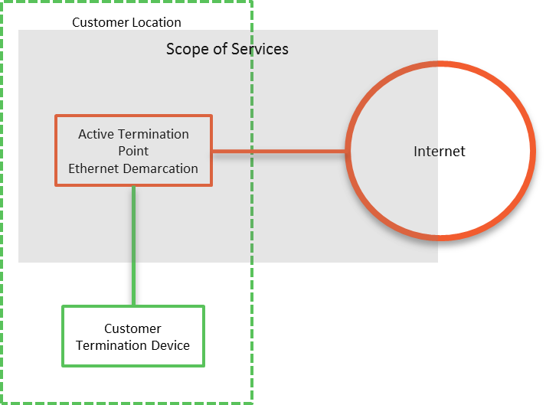  Figure 1: Core Internet Uplink  The Service must provide all components within the scope area highlighted and provide Common Services as per the Common Services schedule.  Services will be differentiated by the access network that is used, in terms of:  - Type; head-end, tail  - Physical layer; satellite, fixed wireless, copper, fibre  - Provider; respondents, NBN, 3rd party  - NBN Traffic Class; TC4, TC2, Enterprise Ethernet
Service Deliverables | The Base Service will provide:  - Connectivity to the Internet for International and National carriage.  - The Service should provide a range of Eligible Customer selectable bandwidths.  - The bandwidth through the Supplier network should be guaranteed i.e. uncontended.  - Outside the Supplier network the bandwidth is expected to be best efforts; however, the expectation is that the contracted bandwidth is available for most of the time.  - Full proactive management of the Service, including monitoring and pro-active response for capacity and availability.  - A standards-based Ethernet termination to connect to Eligible Customer equipment.  - Basic Denial of Service protection.  Service Options that Eligible Customers are interested in, and could also be provided are:  - A CPE device to act as a gateway and connect directly to the Eligible Customer LAN.  - Advanced Denial of Service protection.  - Traffic engineering, to control traffic allocation of bandwidth for different application types.

Internet Access
Service Overview | This Service is where an Eligible Customer requires Internet access at a location, and the Eligible Customer requires the Supplier to:  - Monitor and proactively manage availability and capacity.  - Provide an Ethernet termination point.  This service is characterised by its lower of QoS, compared to Core Internet Uplink, and contended bandwidth tiers. This service is suitable for access sites.  This Service provides connectivity to the Internet as per Figure 1 below.  Figure 2: Internet Access  The Service must provide all components within the scope area highlighted and provide Common Services as per the Common Services schedule.  Services will be differentiated by the access network that is used, in terms of:  - Type; head-end, tail  - Physical layer; satellite, fixed wireless, copper, fibre  - Provider; respondents, NBN, 3rd party  - NBN Traffic Class; TC4, TC2, Enterprise Ethernet
Service Deliverables | The Base Service will provide:  - Connectivity to the Internet for International and National carriage.  - The Service should provide a range of Eligible Customer selectable tiers. Each tier will have its own bandwidth and performance criteria.  - Bandwidth within the Supplier network may be contended or uncontended, depending on the Service tier.  - Outside the Supplier network the bandwidth is expected to be best efforts; however, the expectation is that the contracted bandwidth is available for most of the time.  - Full proactive management of the Service, including monitoring and pro-active response for capacity and availability.  - A standards-based Ethernet termination to connect to Eligible Customer equipment.  - Basic Denial of Service protection.  Service Options that Eligible Customers are interested in, and could also be provided are:  - A CPE device to act as a gateway and connect directly to the Eligible Customer LAN.  - Advanced Denial of Service protection.  - Traffic engineering, to control traffic allocation of bandwidth for different application types.

Peering Access
Service Overview | This Service is where an Eligible Customer requires direct, uncontended access to content providers or subscriber aggregation organisations, and the Eligible Customer requires the Supplier to:  - Provide access to a Peering network  - Monitor and proactively manage availability and capacity.  - Provide an Ethernet termination point.  This Service provides connectivity to Peering as per Figure 3 below.  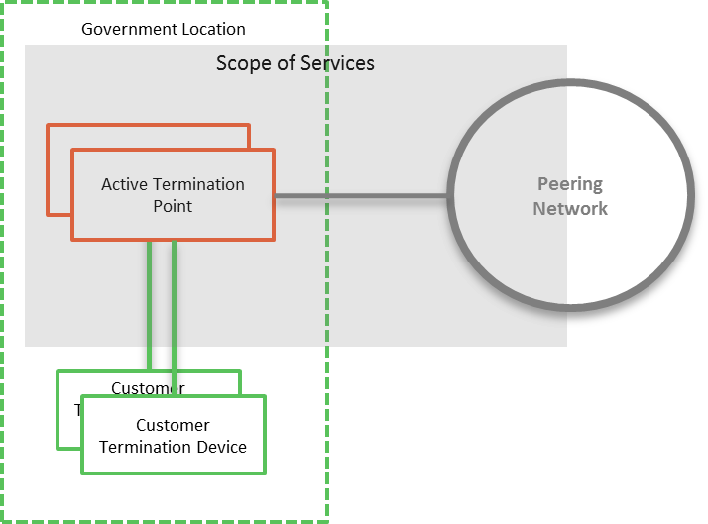  Figure 3: Peering Access  The Service must provide all components within the scope area highlighted and provide Common Services as per the Common Services schedule.
Service Deliverables | The Base Service will provide:  - Connectivity to the Peering Network, and reachability to all Open Peering organisations on the Peering Network.  - The Service should provide a range of Eligible Customer selectable bandwidths.  - Full proactive management of the Service, including monitoring and pro-active response for capacity and availability.  - A standards-based Ethernet termination point to connect to Eligible Customer equipment.  Service Options that Eligible Customers are interested in, and could also be provided are:  - Selective Peering with organisations on the Peering Network, typically via a separate logical network and with point-to-point routing.  - Restricted/Closed peering with organisations, typically on via dedicated connectivity and not via the Peering Network.

Service Category – Internet Uplink and Access Add-ons

Internet Firewall
Service Overview | This Service is where an Eligible Customer requires a managed firewall service to provide protection from the Internet, and the Eligible Customer requires the Supplier to:  - Provide the Firewall as a managed service.  - Monitor and proactively manage availability, capacity, and performance.  - Provide an Ethernet termination point.  - Connect to one or multiple upstream Internet or other network providers.  This Service provides connectivity between Untrusted networks and the Eligible Customer Termination Devices as per Figure 4Error! Reference source not found. below.  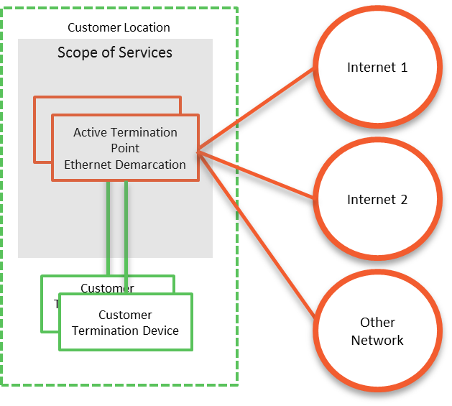  Figure 4: Internet Firewall  The Service must provide all components within the scope area highlighted and provide Common Services as per the Common Services schedule.
Service Deliverables | The Base Service will provide:  - The ability to terminate multiple networks, and control the traffic flow between networks.  - Full proactive management of the Service and interconnection points, including monitoring and pro-active response for capacity, availability, security, and performance. Significant events must also be proactively logged and diagnosed.  - Grey level diagnostics, to determine which interconnecting Supplier needs to take ownership of an incident or problem.  - A standards-based Ethernet termination point at each Data Centre to connect to Eligible Customer equipment.  - The ability to apply firewall policies based on Eligible Customer requirements.  - The ability to alert and/or filter traffic based on known behaviour.  Service Options that Eligible Customers are interested in, and could also be provided are:  - Enhanced monitoring and alerting of behaviour patterns i.e. not reliant on signatures.  - Workflow and Audit management.  - Enhanced Unified Threat Management, such as sandboxing and scanning for malicious content.

DNS Hosting
Service Overview | This Service is where an Eligible Customer requires Domain Name Hosting to support reachability of their applications, and the Eligible Customer requires the Supplier to:  - Host domain names.  - Monitor and proactively manage availability, capacity, and performance.  - Provide access to the service over the Internet.  This Service provides Domain Name Hosting as per Figure 5 below. Where internal DNS services are provided a termination is required at the Data Centres. For external hosting, the Service could be provided entirely from the Internet.  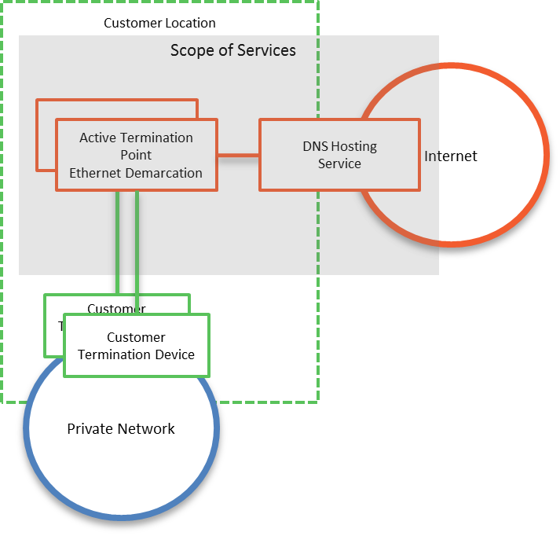  Figure 5: Domain Name Hosting  The Service must provide all components within the scope area highlighted and provide Common Services as per the Common Services schedule.
Service Deliverables | The Base Service will provide:  - The ability to host domain names and provide reachability for domain name resolution from the Internet.  - Full proactive management of the Service, including monitoring and pro-active response for capacity, availability, and performance.  - A standards-based Ethernet termination point at each Data Centre to connect to Eligible Customer equipment, where internal DNS services are provided.  Service Options that Eligible Customers are interested in, and could also be provided are:  - Advanced DNS resolution, for example DNS load balancing algorithms  - Internal DNS resolution services  - IP address Management, and automated DNS record updates

Web Content Filtering
Service Overview | This Service is where there are many Eligible Customer devices that need to access the Internet and require protection to ensure that the devices are not compromised and that the Internet sites being accessed are in line with the Eligible Customer policies.  The Eligible Customer require the Supplier to:  - Monitor and proactively manage availability, capacity, security, and performance of the Service.  - Provide filtered connectivity to the Internet, including the Internet Access.  - Provide connectivity for Eligible Customer devices from the Internet and from an interconnection at the Government Data Centres.  This Service provides connectivity to the Internet as per Figure 6 below.  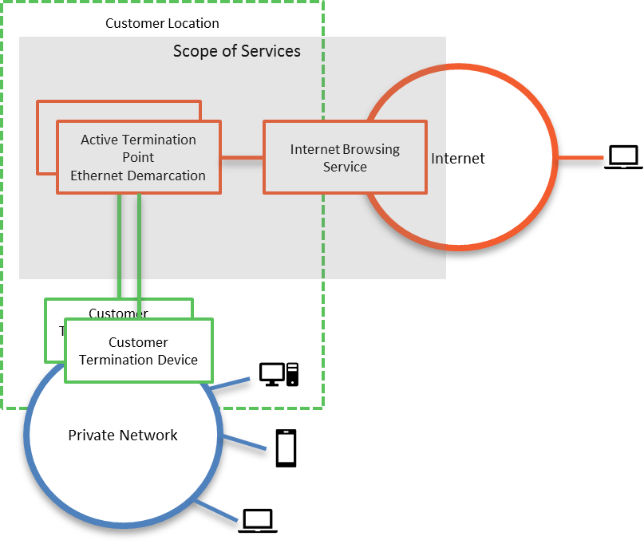  Figure 6: Internet Browsing  The Service must provide all components within the scope area highlighted and provide Common Services as per the Common Services schedule.
Service Deliverables | The Base Service will provide:  - Internet Access for Eligible Customer devices connecting to the Service. The Service should provide a range of Eligible Customer selectable bandwidths.  - The ability for Eligible Customer devices to connect to the Service via their Private Network or via the Internet.  - Full proactive management of the Service and interconnection points, including monitoring and pro-active response for capacity, availability, and performance.  - A standards-based Ethernet termination at each location to connect to Eligible Customer equipment.  - The ability to apply security policies based on Eligible Customer requirements, with policies able to be applied for the organisation, group, and individual.  - The ability to alert and/or filter traffic based on known behaviour, malicious content, and content type.  - The ability to prevent or allow access to web sites, based on categories, white lists, or black lists.  - The ability to prevent or allow access to web sites (URL filtering), based on categories, white lists, or black lists.  - The filtering policy will be based on the group that the users belong to.  - There are potentially many distinct groups with different policy lists.  Service Options that Eligible Customers are interested in, and could also be provided are:  - Cloud Access Security Brokerage

Email Protection
Service Overview | This Service is where the Eligible Customer has devices that need to send and receive emails over the Internet and require protection to ensure that the devices are not compromised and that the emails being sent and received are in line with the Eligible Customer policies.  The Eligible Customer require the Supplier to:  - Monitor and proactively manage availability, capacity, and performance of the Service.  - Provide filtering of email content to and from the Internet, and provide the Internet Access.  - Provide connectivity for Eligible Customer Email platforms to the Internet from interconnection points at the Eligible Customer’s location(s).  This Service provides connectivity to the Internet for Email as per Figure 7 below.  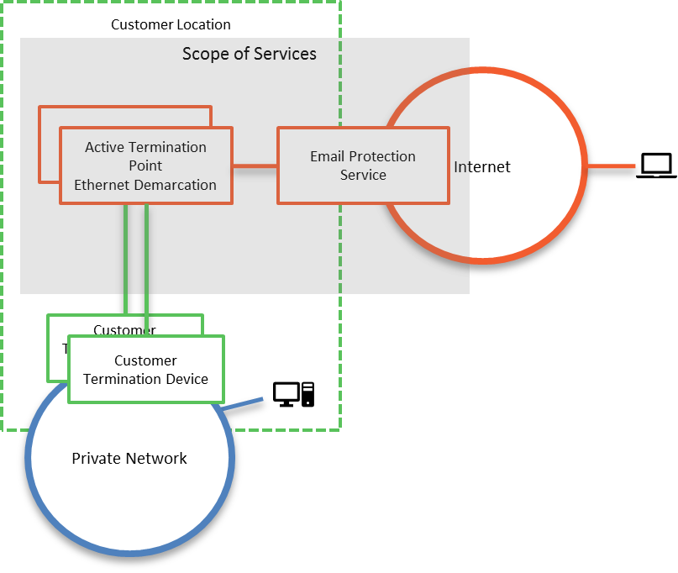  Figure 7: Email Protection  The Service must provide all components within the scope area highlighted and provide Common Services as per the Common Services schedule.
Service Deliverables | The Base Service will provide:  - Internet Access for third-party email hosts connecting to the Service. The Service should provide a range of Eligible Customer selectable bandwidths.  - The ability for Eligible Customer Email platforms to connect to the Service via their Private Network.  - Full proactive management of the Service and interconnection points, including monitoring and pro-active response for capacity, availability, and performance.  - A standards-based Ethernet termination point at each Data Centre to connect to Eligible Customer equipment.  - The ability to apply security policies based on Eligible Customer requirements, with policies able to be applied for the organisation, group, and individual.  - The ability to alert and/or filter traffic based on known behaviour, malicious content, and content type.  - The ability to prevent or allow access to domains, based on categories, white lists, or black lists.  - The ability to detect and quarantine unsolicited email, and to provide a mechanism for the users to view quarantined email and release the email if required.  Service Options that Eligible Customers are interested in, and could also be provided are:  - Hold and release of email, based on polices  - Classification of emails, through user prompts and rules

Glossary
Term or short form | Long-form | Definition
aaS | as-a-Service | An item, or grouping of items, made available to a customer as a service
Active Termination |  | Where the Service Provider provide a device that terminates the service at a site and enables end-to-end management.
ADSL | Asymmetric Digital Subscriber Line
APN | Access Point Name | A gateway between a mobile network and another network, such as the Internet or a Private WAN.
bps or bit/s | Bits per second
BYO | Bring your own
CAB | Change Advisory Board
Circuit |  | For data connections, a circuit a path that data transverses between two points. A circuit is a component of a Service.
CMS | Configuration Management System
Contract Authority |  | The central entity that is accountable and responsible for the Head Agreements of the TPAs
CoS | Class of Service
 |  | TPA Release Version
CSI | Continual Service Improvement
Customer |  | NSW Government Agency, or any organisation procuring services from the Service Catalogues.
CPE | Customer Premise Equipment | A device that is used by Service Providers to terminate services at a site.
Customer Termination Device |  | A Customer device that is connected to the Provider's equipment
DHCP | Dynamic Host Control Protocol
DISS | Digital Information Security Strategy
DoS (or DDoS) | Denial of service (or distributed denial of service) | An attack that attempts to make a service unavailable by overwhelming it with traffic from multiple sources.
DWDM | Dense Wavelength Division Multiplexing
Error |  | A design flaw or malfunction that causes a failure of one or more IT services or other configuration items.
Event |  | A change of state that has significance for the management of a service.
Gateway device |  | A layer 3 device at a site that acts as the sites router, to transmit packets to the WAN. Host devices have a gateway device configured, typically via DHCP.
Gbps or Gbit/s | Giga (billion) bits per second
Grey Area Diagnostics |  | The process to proactively diagnose in-scope services and interconnections to help identify the cause of an incident or problem. The result is to identify that the cause of the incident or problem:  - Is caused by in-scope services  - Is not caused by in-scope services  - Could be caused by in-scope services, and further diagnostics are required
ICT | Information and Communications Technology
ICT Risk Management |  | Information Communication Technology (ICT). The NSW Digital Information Security Policy mandates a risk-based approach to securing information, based on the ISO 27001 standard. DFSI has implemented a framework in line with the policy, with ICT risks being managed through an Information Security Management System (ISMS).
Incident |  | An unplanned interruption to a service or a reduction in the Quality of a service. Failure of a configuration Item that has not yet impacted service is also an Incident.
IP | Internet Protocol
IPSLA | Internet Protocol Service Level Agreement | Cisco IOS feature that allows for the collection of network performance information.
ISM | Information Security Management
ISMS | Information Security Management System
ISO | International Standards Organisation
ITSM | IT Service Management
IVR | Interactive Voice Response
kbps or kbit/s | Kilo (thousand) bits per second
Known Error |  | A Problem that has a documented root cause and workaround.
Location, Site |  | A Customer site or location is a place where services are to be delivered. Depending on the service, this may not necessarily be a physical building.
MACD | Move, Add, Change or Delete
MAN | Metropolitan Area Network
Mbps or Mbit/s | Mega (million) bits per second
MNO | Mobile Network Operator | Provider of wireless/mobile communications services that owns or controls all the elements necessary to sell and deliver services to an end user, e.g. radio spectrum, wireless network infrastructure, back haul, billing, customer care, provisioning systems and repair capabilities.
MVNO | Mobile Network Operator | Provider of wireless/mobile communications services that does not own the wireless network infrastructure over which it provides services to its customers. Instead they enter a business agreement with a MNO to obtain bulk access to network services at wholesale rates. They do have their own customer service, billing systems, marketing, and sales personnel.
MPLS | Multi-Protocol Label Switching
MTU | Maximum Transmission Unit
NBN | National Broadband Network
NBN Co |  | The entity responsible for the design, build and operation of the NBN
NFV | Network Function Virtualisation
NIVR | Network Interactive Voice Response
OADM | Optical Add-Drop Multiplexer
Operational Risk |  | Risks associated with business-as-usual activities at the Division / Business Unit / Related Entity level that is normally managed within that area, unless the level of risk requires a review by the DFSI Executive and/or Secretary.
OSS | Operational Support System
OTT | Over-the-top
Passive Termination |  | Where the Service provider provides a physical termination point which can’t be monitored.
PE | Provider Edge
Peering |  | The exchange of data directly between Content Providers and Customers, rather than via the Internet.
Performance |  | A measure of what is achieved or delivered by a system, person, team, process or service
POI | Point of Interconnect
POP | Point of Presence
Priority |  | The value given to an Incident, Problem or Change to indicate its relative importance in order to ensure the timeframe within which action, such as Response and Resolution, is required.
Private Data Network |  | A network or networks that utilises private infrastructure to deliver physically or logically private services
Problem |  | A cause of one or more Incidents. The cause is not usually known at the time a Problem Record is created, and the Problem Management Process is responsible for further investigation.
Public Data Network |  | A network or networks that utilises publicly available, shared infrastructure such as mobile networks or the Internet
Public Holidays |  | All NSW public holidays as gazetted, except for Bank Holidays specific to only banks and financial institutions as per the Retail Act.
QoS | Quality of Service
RACI | Responsible, Accountable, Contributor, Informed
Resolver Group |  | Specialised groups that have the knowledge and skill to solve an Incident or Problem.
R-OADM | Reconfigurable Optical Add-Drop Multiplexer
Root Cause |  | The underlying or original cause of an incident or problem.
RSP | Retail Service Provider
Sandboxing |  | A security mechanism for separating untested or untrusted programs or code to mitigate system failures or software vulnerabilities from spreading.
Satellite |  | Satellite based connectivity to deliver NBN connectivity
SDN | Software Defined Network
SD-WAN | Software Defined Wide Area Network
SD-WANaaS | SD-WAN-as-a-Service
Service Window |  | Service window is defined as the timeframe within which service availability and service management (incident response, incident resolve) are measured and managed.
Significant Event |  | This is an event that materially impacts a Customer, and is likely to be a P1 or P2.
SIP | Session Initiation Protocol.
SLA | Service Level Agreement
SoR | Statement of Requirements
TDM | Time Division Multiplexing
TPA | Telecommunications Purchasing Arrangements
User |  | A person who uses a service on a day-to-day basis.
VIP | People with critical roles within an organisation, and identified to Service Providers.
VNF | Virtual Network Function
VPN | Virtual Private Network
WAN | Wide Area Network
WoG or WofG | Who of government | All Clusters and Agencies within the NSW Government.

Strategic Sourcing | ICT / Digital Sourcing | Department of Customer Service

Address: Level 23, McKell Building, 2-24 Rawson Place, Sydney NSW 2000

E-mail: Strategic.Sourcing@customerservice.nsw.gov.au

