Service Description

Mobile

Document Control
Status | Drafted for digital.nsw.gov.au
Author’s Name  Position | Matt Duniam  Network Architect
Category (Sub-Category) | ICT (Telecommunications)
Summary | Service Description for Fixed Data under the Telecommunications Purchasing Arrangements

Revision record
Please note significant document changes with a version increment of 1.0. Minor administrative changes, where the meaning or intention of the document is not altered should increase by an increment of 0.1.
Version | Date | Author | Summary of changes
1.0 | 19/12/2017 | Matt Duniam | Release version  Released as part of RFx101331
2.0 | 02/06/2019 | Matt Duniam | Updated to include a broader set of services.  Released as part of RFx133881
2.1 | 06/04/2020 | Matt Duniam | Minor update for digital.nsw.gov.au

Copyright
This work is licensed under the Creative Commons Attribution-NoDerivatives 4.0 International License. Terms for use can be found at https://www.customerservice.nsw.gov.au/copyright and the applicable license for use is at http://creativecommons.org/licenses/by-nd/4.0/.
© State of New South Wales through Department of Customer Service, 2020.

Table of Contents

Document Control 2

1. Service Tower Description 4

2. Service Category – Mobile Connectivity Services 6
2.1 Mobile Voice, SMS and Data Connection 6
2.2 Mobile Data Only Connection 7

3. Service Category – Mobile Data Pool Services 9
3.1 Mobile Data Pool 9
3.2 Mobile Voice Pool 9

4. Service Category – Mobile Device as a Service 11
4.1 Mobile Device as a service 11

5. Service Category – Mobile Device Management Services 13
5.1 Mobile Device Security Services 13
5.2 Mobile Device Management – Managed Service 14

6. Service Category – Managed Telemetry/M2M Service 16
6.1 Managed Telemetry/M2M Service 16

7. Service Category – Bulk SMS 18
7.1 Bulk SMS 18

8. Glossary 19

Service Tower Description
Mobile Services provide increased flexibility in ways of working for users and options for process automation through mobile voice and data connectivity services. The objective being to accelerate interactions across Eligible Customers, with citizens and third parties.
The primary use cases enabled by the Services within this service tower are as follows,
- Mobile Voice, SMS and Data Connection – enable user’s smartphones or basic mobile phones. Includes all normal voice and SMS usage by default to eliminate the potential for bill shock and overage. Mobile data allocations included which are managed through Mobile Data Pool(s).
- Mobile Data Only Connection – enable data devices used by individuals or deployed in small sites, e.g. a user’s tablet or laptop, a mobile router at a small site. Mobile data allocations included which are managed through Mobile Data Pool(s).
- Mobile Telemetry or machine-to-machine (M2M) Connection – enable devices used with machine-to-machine systems that send low volumes of data or readings to and from a central service / platform, e.g. remote dust sensor, vehicle management solution. M2M data allocations included which are managed through Mobile Data Pool(s).
- Mobile Data Pool – provides ability to aggregate the mobile data across one or more Eligible Customer’s mobile connections to eliminate the need to actively manage high and low volume users. Defines the process and costs to top-up a data pool if needed. Eligible Customers can map their connections to one or more data pools, i.e. many to one.
- Mobile Device as a service – enables Eligible Customers to outsource the ownership of mobile devices along with the overhead related to the management of their mobile device fleet. The objective being to minimise the downtime of mobile users.
- Mobile Device Security Services – provides a toolset to Eligible Customers that enables them to actively manage their security posture related to mobile devices and users. This ensures applications and information is safe while productivity benefits are maximised.
- Mobile Device Management – Managed Service – enables Eligible Customers to outsource the day-to-day management of the Mobile Device Security Services, i.e. these are otherwise a self-service capability that Eligible Customers must administer.
These services are expected to continually evolve as technology changes and the security demands related to mobile devices escalates.
It is expected that individual services may be consumed from different Suppliers, and the services will be delivered in a modular fashion to facilitate that. Eligible Customers, or their designated third party, are expected to aggregate Mobile Services form various Suppliers and any integrations with other towers in their environment.
The services within this catalogue must meet the requirements for Mobile Services defined in the Requirements Schedule and comply with the Common Services Catalogue.
This catalogue defines the minimum set of base services required by the Eligible Customers within NSW Government and provides a generalised overview of their current states.

Service Category – Mobile Connectivity Services

Mobile Voice, SMS and Data Connection
Service Overview | This Service is where users require personal mobility to complete their role functions effectively & efficiently, and the Eligible Customer requires known cost per service for all usage.  As the Service is delivered and managed as a service it will be up to the Supplier to determine if there are availability or performance issues, and to take the lead on their resolution while reporting them to the Eligible Customer.  This Service provides personal mobile connectivity as per Figure 1 below, where Option A has the mobile data service connected directly to the public internet, while Option B has all mobile data routed directly to an APN connection on the Eligible Customers private network.  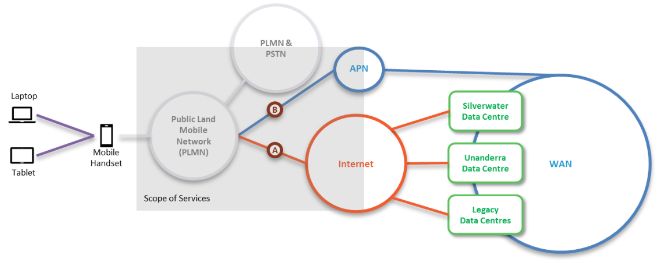  Figure 1: Personal mobility demarcation and scope  The Service must provide all components within the scope area highlighted and provide Common Services as per the Common Services schedule.
Service Deliverables | The Base Service will provide:  - A range of Eligible Customer selectable calling plan options to standard Australian fixed and mobile numbers, i.e. mobile numbers from any provider in Australia as well as any domestic telephone numbers that start with 02,03,07 or 08, i.e. excludes 1900 numbers.  - Unlimited SMS to standard Australian mobile numbers, i.e. mobile numbers from any provider in Australia.  - Public internet connectivity, Option “A” in Figure 1, with an allocation of data per connection to an Eligible Customer Data Pool.  - Mobile device internet connection sharing options including tethering and personal hotspot e.g. laptops/smartphones/tablets to smartphone.  - SIM card included, where required.  - Open (no minimum term) term contract per connection.  - Ability to view and manage usage at various granularities, i.e. whole pool to user level.  Service Options that Eligible Customers are interested in, and could also be provided are:  - Raw Mobile Connection - all usage chargeable, i.e. Voice, SMS and/or Data.  - Private APN, Option “B” in Figure 1 – private Access Point Name (APN) option captures all data traffic from mobile device and routes it back to an IP endpoint on the Eligible Customer’s private network.  - VIP service option/concierge – minimise down time and provide extra support for high value/cost users. This service is a suitable where the impact of having such individuals offline or out of contact is material and worth directly mitigating.  - Coverage loss logging and reporting – tool-based recording of performance, particularly coverage, across all mobile connections of an Eligible Customer. Remediation planning with Eligible Customer to explore options to address high impact locations and scenarios.  - International Roaming Services.  - Handset subsidy – in return for a term commitment on Mobile Services, i.e. 24 or 36 months, Eligible Customers receive a subsidy on the upfront device purchase costs.  - Additional profiles - Service providers can propose additional profiles between Raw Mobile Connection and this base service, i.e. specific allocations of calling, SMS and/or data. Must include mechanism to automatically manage mapping of users to profiles to avoid administration overhead otherwise created.  - Options for Eligible Customers to choose combinations of access to Voice, SMS and Data.  - Unlimited on-net calls to other Eligible Customer numbers, including other Government agencies.

Mobile Data Only Connection
Service Overview | This Service is where users or sites require mobile data to function, and the Eligible Customer requires known cost per connection for usage.  As the Service is delivered and managed as a service it will be up to the Supplier to determine if there are availability or performance issues, and to take the lead on their resolution while reporting them to the Eligible Customer.  This Service provides personal mobile connectivity as per Figure 2 below, where Option A has the mobile data service connected directly to the public internet, while Option B has all mobile data routed directly to an APN connection on the Eligible Customers private network.  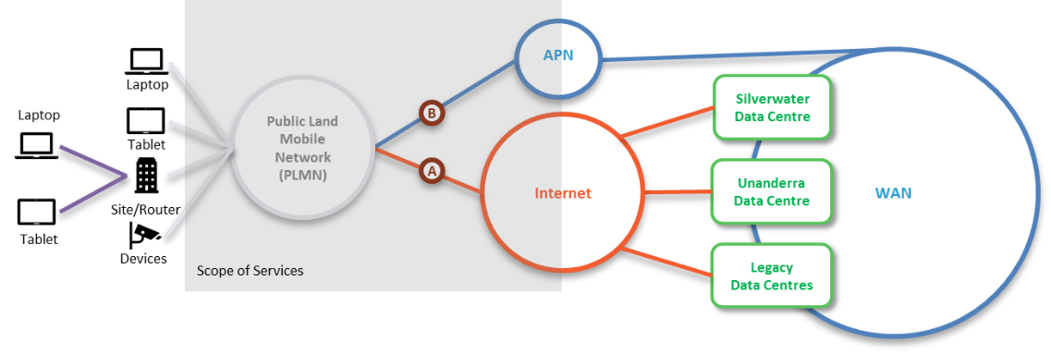  Figure 2: Mobile Data Only Connection demarcation and scope  The Service must provide all components within the scope area highlighted and provide Common Services as per the Common Services schedule.
Service Deliverables | The Base Service will provide:  - Public internet connectivity, Option “A” in Figure 2, with an allocation of data per connection to an Eligible Customer Data Pool.  - Mobile device internet connection sharing options including tethering and personal hotspot e.g. laptops/smartphones/tablets to smartphone  - SIM card included, where required.  Service options that Eligible Customers are interested in, and could also be provided are:  - International Data Roaming Services  - Private APN, Option “B” in Figure 2 – private Access Point Name (APN) option captures all data traffic from mobile device and routes it back to an IP endpoint on an Eligible Customer’s private network.  - VIP service option/concierge – minimise down time and provide extra support for high value/cost users. This service is a suitable where the impact of having such individuals offline or out of contact is material and worth directly mitigating.  - Device subsidy – in return for a term commitment on Mobile Services, i.e. 24 or 36 months, Eligible Customers receive a subsidy on the upfront device purchase costs.  - Coverage loss logging and reporting – tool-based recording of performance, particularly coverage, across all mobile connections of an Eligible Customer. Remediation planning with Eligible Customer to explore options to address high impact locations and scenarios.

Service Category – Mobile Data Pool Services

Mobile Data Pool
Service Overview | This Service is where Eligible Customers need the benefits of mobile data without the need to micro manage variations in usage across users and the Eligible Customer also needs options to increase the aggregate size of the data pool resulting from its Mobile connections.  As the Service is delivered and managed as a service it will be up to the Supplier to determine if there are availability or performance issues with deliverables, and to take the lead on their resolution while reporting them to the Eligible Customer.  No incremental costs, outside the underlying connection charges, exist to establish one of multiple data pools. Incremental data pool costs are only chargeable to top-up a data pool.  Eligible Customers or groups of multiple Eligible Customers may elect to have one or multiple mobile data pools with specific connections mapped to each.  The Service must provide all components within the scope area highlighted and provide Common Services as per the Common Services schedule.
Service Deliverables | The Base Service will provide:  - Mechanism to aggregate mobile data contributions per connection into one or more Mobile Data Pools.  - No charge to establish or maintain one or multiple data pools.  - Usage alerts and reporting to designated data pool administrators.  Service options that Eligible Customers are interested in, and could also be provided are:  - Ability to increase the monthly size of a mobile Data Pool at pre-agreed rates.  - Automatic data pool top ups in pre-defined increments.

Mobile Voice Pool
Service Overview | This Service is where Eligible Customers need the benefits of mobile voice without the need to micro manage variations in usage across users and the Eligible Customer also needs options to increase the aggregate size of the voice pool resulting from its Mobile connections.  As the Service is delivered and managed as a service it will be up to the Supplier to determine if there are availability or performance issues with any deliverables, and to take the lead on their resolution while reporting them to the Eligible Customer.  No incremental costs, outside the underlying connection charges, exist to establish one of multiple voice pools. Incremental voice pool costs are only chargeable to top-up a voice pool.  Eligible Customers or groups of multiple Eligible Customers may elect to have one or multiple mobile voice pools with specific connections mapped to each.  The Service must provide all components within the scope area highlighted and provide Common Services as per the Common Services schedule.
Service Deliverables | The Base Service will provide:  - Mechanism to aggregate mobile voice contributions per connection into one or more Mobile Voice Pools.  - No charge to establish or maintain one or multiple voice pools.  - Usage alerts and reporting to designated voice pool administrators.  Service options that Eligible Customers are interested in, and could also be provided are:  - Ability to increase the monthly size of a mobile Voice Pool at pre-agreed rates.  - Automatic voice pool top ups in pre-defined increments.

Service Category – Mobile Device as a Service

Mobile Device as a service
Service Overview | This Service is a good option where Eligible Customers want to outsource the management of their mobile devices or mobile device fleet, and the Eligible Customer wants to avoid the upfront cost of mobile device hardware.  As the Service is delivered and managed as a service it will be up to the Supplier to determine if there are availability or performance issues, and to take the lead on their resolution while reporting them to the Eligible Customer.  This Service provides mobile devices as a service as per Figure 3 below, where Eligible Customers may look to consume this service for some of their Mobile Handset and/or Tablet mobile devices or for their entire mobile device fleet.  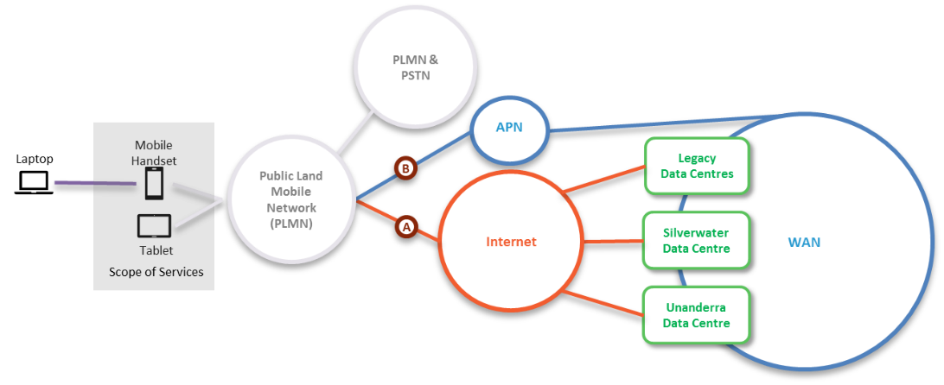  Figure 3: Mobile Device as a Service demarcation and scope  Service provider will manage a process to add and remove devices from an Eligible Customer’s approved range of mobile devices.  The Service must provide all components within the scope area highlighted and provide Common Services as per the Common Services schedule.
Service Deliverables | The Base Service will provide:  - Selected mobile device, from approved device range and provider  - Initial provisioning and delivery of new handset  - Repair and replacement service with user concierge support  - Disposal of devices at the end of agreed duration  - Asset Management for an Eligible Customer’s mobile device fleet  - Options to include approved accessories  Service options that Eligible Customers are interested in, and could also be provided are:  - Mobile device as a service excluding asset ownership.

Service Category – Mobile Device Management Services

Mobile Device Security Services
Service Overview | This Service is where an automated mechanism is required to ensure the security posture of an Eligible Customer’s mobile devices, including management of the applications that can be accessed along with protection of the information they expose. In addition, the Eligible Customer requires this capability across all mobile devices even those that never attach to the Eligible Customer’s private network.  This Service delivers a capability / toolset that the Eligible Customer then administers to deliver the required level of Mobile Device security.  This Service provides mobile device security management as per Figure 4 below.  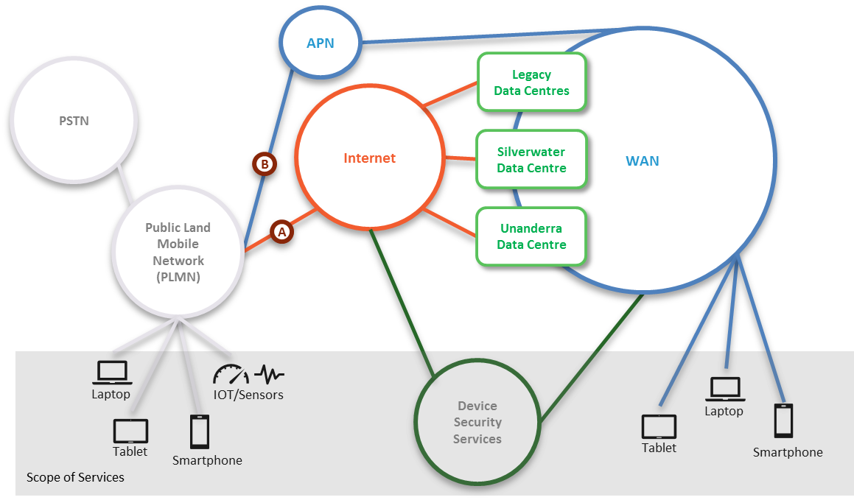  Figure 4: Mobile Device Security Services demarcation and scope  The Service must provide all components within the scope area highlighted and provide Common Services as per the Common Services schedule.  If an Eligible Customer is looking to outsource the operation of this capability / toolset, then 5.2 below should also be considered.
Service Deliverables | The Base Service will provide:  - Mobile device management including remote diagnostics and support for multiple OS and device types.  - Mobile Application and Digital Certificate management.  - Security Policy Management.  - Admin and user self-service portals.  Service options that Eligible Customers are interested in, and could also be provided are:  - Transition and/or project professional service – including training of the Eligible Customers mobile fleet administrators, initial device enrolment, design and implementation of any integrations required into wider ICT environment, and wrapping of targeted applications.  - Identity Management and Federated single sign-on  - Conditional Content and Email Access Management  - Mobile Application containerisation  - Per-application VPN Tunnelling and Application wrapping  - Mobile Application deployment

Mobile Device Management – Managed Service
Service Overview | This Service is where Mobile Device Security Services are needed, and the Eligible Customer requires the day-to-day operation of that capability to be outsourced.  As the Service is a service management offering the Supplier will determine if there are availability or performance issues with it or the related underlying capability, lead their resolution, and report these to the Eligible Customer.  This Service provides administration of the mobile device security management service above in 5.1 as per Figure 5 below.  Figure 5: Mobile Device Security Services demarcation and scope  The Service must provide all components within the scope area highlighted and provide Common Services as per the Common Services schedule.
Service Deliverables | The Base Service will provide:  - Day to day operation of Mobile Device Security Management Capability.  - Delivery of non-user specific changes, e.g. wrapping new applications and update security policies.  Service options that Eligible Customers are interested in, and could also be provided are:  - N/A

Service Category – Managed Telemetry/M2M Service

Managed Telemetry/M2M Service
Service Overview | This service is where an Eligible Customer requires private connectivity for a device/machine for the explicit purpose of machine-to-machine (M2M), telemetry or IoT communication. The service will also include an application to facilitate the management of the machines/devices.  As the Service is delivered and managed as a service it will be up to the Supplier to determine if there are availability or performance issues, and to take the lead on their resolution while reporting them to the Eligible Customer.  This service provides connectivity as per Figure 5 below, where Option A has the mobile data service connected directly to the public internet, while Option B has all mobile data routed directly to an APN/VPN connection on the Eligible Customers private network.  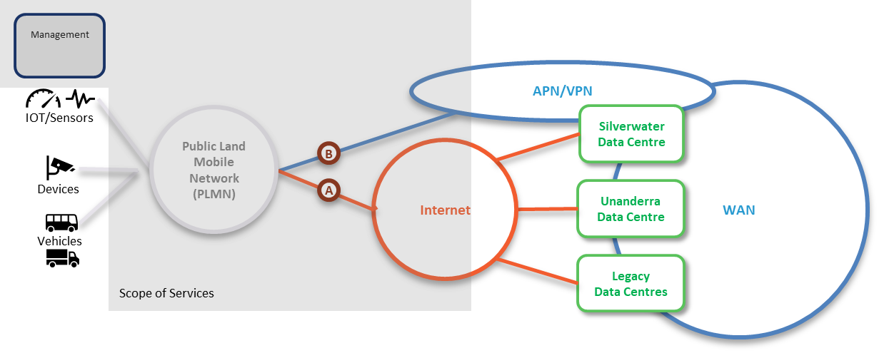  Figure 6: Mobile Data Only Connection demarcation and scope  The Service must provide all components within the scope area highlighted and provide Common Services as per the Common Services schedule.
Service Deliverables | The Base Service will provide:  - Connectivity as per Option “A” in the Figure above, with an allocation of data per connection to an Eligible Customer Data Pool.  - SIM card included, where required.  - Access to a web-based portal to manage the M2M service.  Service options that Eligible Customers are interested in, and could also be provided are:  - Private APN, Option “B” in Figure 2 – private Access Point Name (APN) option captures all data traffic from mobile device and routes it back to an IP endpoint on an Eligible Customer’s private network.  - Device subsidy – in return for a term commitment on Mobile Services, i.e. 24 or 36 months, Eligible Customers receive a subsidy on the upfront device purchase costs.  - Coverage loss logging and reporting – tool based recording of performance, particularly coverage, across all mobile connections of an Eligible Customer. Remediation planning with Eligible Customer to explore options to address high impact locations and scenarios.

Service Category – Bulk SMS

Bulk SMS
Service Overview | This service is where an Eligible Customer requires the ability to send SMS’s to multiple recipients simultaneously, via a web-based application or via API integration.  As the Service is delivered and managed as a service it will be up to the Supplier to determine if there are availability or performance issues, and to take the lead on their resolution while reporting them to the Eligible Customer.  The Service must provide all components within the scope area highlighted and provide Common Services as per the Common Services schedule.
Service Deliverables | The Base Service will provide:  - Access to a web-based portal for the management and operation of the service.  - Logging of successful messages

Glossary
Term or short form | Long-form | Definition
aaS | as-a-Service | An item, or grouping of items, made available to a customer as a service
Active Termination |  | Where the Service Provider provide a device that terminates the service at a site and enables end-to-end management.
ADSL | Asymmetric Digital Subscriber Line
APN | Access Point Name | A gateway between a mobile network and another network, such as the Internet or a Private WAN.
bps or bit/s | Bits per second
BYO | Bring your own
CAB | Change Advisory Board
Circuit |  | For data connections, a circuit a path that data transverses between two points. A circuit is a component of a Service.
CMS | Configuration Management System
Contract Authority |  | The central entity that is accountable and responsible for the Head Agreements of the TPAs
CoS | Class of Service
 |  | TPA Release Version
CSI | Continual Service Improvement
Customer |  | NSW Government Agency, or any organisation procuring services from the Service Catalogues.
CPE | Customer Premise Equipment | A device that is used by Service Providers to terminate services at a site.
Customer Termination Device |  | A Customer device that is connected to the Provider's equipment
DHCP | Dynamic Host Control Protocol
DISS | Digital Information Security Strategy
DoS (or DDoS) | Denial of service (or distributed denial of service) | An attack that attempts to make a service unavailable by overwhelming it with traffic from multiple sources.
DWDM | Dense Wavelength Division Multiplexing
Error |  | A design flaw or malfunction that causes a failure of one or more IT services or other configuration items.
Event |  | A change of state that has significance for the management of a service.
Gateway device |  | A layer 3 device at a site that acts as the sites router, to transmit packets to the WAN. Host devices have a gateway device configured, typically via DHCP.
Gbps or Gbit/s | Giga (billion) bits per second
Grey Area Diagnostics |  | The process to proactively diagnose in-scope services and interconnections to help identify the cause of an incident or problem. The result is to identify that the cause of the incident or problem:  - Is caused by in-scope services  - Is not caused by in-scope services  - Could be caused by in-scope services, and further diagnostics are required
ICT | Information and Communications Technology
ICT Risk Management |  | Information Communication Technology (ICT). The NSW Digital Information Security Policy mandates a risk-based approach to securing information, based on the ISO 27001 standard. DFSI has implemented a framework in line with the policy, with ICT risks being managed through an Information Security Management System (ISMS).
Incident |  | An unplanned interruption to a service or a reduction in the Quality of a service. Failure of a configuration Item that has not yet impacted service is also an Incident.
IP | Internet Protocol
IPSLA | Internet Protocol Service Level Agreement | Cisco IOS feature that allows for the collection of network performance information.
ISM | Information Security Management
ISMS | Information Security Management System
ISO | International Standards Organisation
ITSM | IT Service Management
IVR | Interactive Voice Response
kbps or kbit/s | Kilo (thousand) bits per second
Known Error |  | A Problem that has a documented root cause and workaround.
Location, Site |  | A Customer site or location is a place where services are to be delivered. Depending on the service, this may not necessarily be a physical building.
MACD | Move, Add, Change or Delete
MAN | Metropolitan Area Network
Mbps or Mbit/s | Mega (million) bits per second
MNO | Mobile Network Operator | Provider of wireless/mobile communications services that owns or controls all the elements necessary to sell and deliver services to an end user, e.g. radio spectrum, wireless network infrastructure, back haul, billing, customer care, provisioning systems and repair capabilities.
MVNO | Mobile Network Operator | Provider of wireless/mobile communications services that does not own the wireless network infrastructure over which it provides services to its customers. Instead they enter a business agreement with a MNO to obtain bulk access to network services at wholesale rates. They do have their own customer service, billing systems, marketing, and sales personnel.
MPLS | Multi-Protocol Label Switching
MTU | Maximum Transmission Unit
NBN | National Broadband Network
NBN Co |  | The entity responsible for the design, build and operation of the NBN
NFV | Network Function Virtualisation
NIVR | Network Interactive Voice Response
OADM | Optical Add-Drop Multiplexer
Operational Risk |  | Risks associated with business-as-usual activities at the Division / Business Unit / Related Entity level that is normally managed within that area, unless the level of risk requires a review by the DFSI Executive and/or Secretary.
OSS | Operational Support System
OTT | Over-the-top
Passive Termination |  | Where the Service provider provides a physical termination point which can’t be monitored.
PE | Provider Edge
Peering |  | The exchange of data directly between Content Providers and Customers, rather than via the Internet.
Performance |  | A measure of what is achieved or delivered by a system, person, team, process or service
POI | Point of Interconnect
POP | Point of Presence
Priority |  | The value given to an Incident, Problem or Change to indicate its relative importance in order to ensure the timeframe within which action, such as Response and Resolution, is required.
Private Data Network |  | A network or networks that utilises private infrastructure to deliver physically or logically private services
Problem |  | A cause of one or more Incidents. The cause is not usually known at the time a Problem Record is created, and the Problem Management Process is responsible for further investigation.
Public Data Network |  | A network or networks that utilises publicly available, shared infrastructure such as mobile networks or the Internet
Public Holidays |  | All NSW public holidays as gazetted, except for Bank Holidays specific to only banks and financial institutions as per the Retail Act.
QoS | Quality of Service
RACI | Responsible, Accountable, Contributor, Informed
Resolver Group |  | Specialised groups that have the knowledge and skill to solve an Incident or Problem.
R-OADM | Reconfigurable Optical Add-Drop Multiplexer
Root Cause |  | The underlying or original cause of an incident or problem.
RSP | Retail Service Provider
Sandboxing |  | A security mechanism for separating untested or untrusted programs or code to mitigate system failures or software vulnerabilities from spreading.
Satellite |  | Satellite based connectivity to deliver NBN connectivity
SDN | Software Defined Network
SD-WAN | Software Defined Wide Area Network
SD-WANaaS | SD-WAN-as-a-Service
Service Window |  | Service window is defined as the timeframe within which service availability and service management (incident response, incident resolve) are measured and managed.
Significant Event |  | This is an event that materially impacts a Customer, and is likely to be a P1 or P2.
SIP | Session Initiation Protocol.
SLA | Service Level Agreement
SoR | Statement of Requirements
TDM | Time Division Multiplexing
TPA | Telecommunications Purchasing Arrangements
User |  | A person who uses a service on a day-to-day basis.
VIP | People with critical roles within an organisation, and identified to Service Providers.
VNF | Virtual Network Function
VPN | Virtual Private Network
WAN | Wide Area Network
WoG or WofG | Who of government | All Clusters and Agencies within the NSW Government.

Strategic Sourcing | ICT / Digital Sourcing | Department of Customer Service

Address: Level 23, McKell Building, 2-24 Rawson Place, Sydney NSW 2000

E-mail: Strategic.Sourcing@customerservice.nsw.gov.au

