Service Description

Network Applications

Document Control
Status | Drafted for digital.nsw.gov.au
Author’s Name  Position | Matt Duniam  Network Architect
Category (Sub-Category) | ICT (Telecommunications)
Summary | Service Description for Network Applications – SD-WANaaS (Telecommunications Purchasing Arrangements)

Revision record
Please note significant document changes with a version increment of 1.0. Minor administrative changes, where the meaning or intention of the document is not altered should increase by an increment of 0.1.
Version | Date | Author | Summary of changes
1.0 | 14/11/2018 | Matt Duniam | RFP release version
1.1 | 06/04/2020 | Matt Duniam | Minor update for digital.nsw.gov.au

Copyright
This work is licensed under the Creative Commons Attribution-NoDerivatives 4.0 International License. Terms for use can be found at https://www.customerservice.nsw.gov.au/copyright and the applicable license for use is at http://creativecommons.org/licenses/by-nd/4.0/.
© State of New South Wales through Department of Customer Service, 2020.

Table of Contents

Document Control 2

1. Introduction 5

2. Service Tower Description – Network Applications 6
2.1 TPA Service Structure 6

3. Service Category Description – SD-WAN 10
3.1 Service Category Modules and Components 11
3.1.1 Security 11
3.1.2 Carriage 12
3.1.3 Hardware - CPE 17
3.1.4 Hardware - Controller 20
3.1.5 Functions 22
3.1.6 Professional Services 23

4. Service Type – SD-WANaaS 25
4.1 SD-WANaaS – Choose Your Carriage 25

5. Price Book 27
5.1 Overview 27
5.2 Underlying Carriage 27
5.3 Service Construction 27
5.4 Response Scenarios 28
5.4.1 Scenario 1 - Pricing responses in all three tabs 28
5.4.2 Scenario 2 - Pricing Responses in "SD-WANaaS - Overlay" and "SD-WANaaS - CPE" only 28
5.4.3 Scenario 3 - Pricing responses in "SD-WANaaS - CPE" and "SD-WANaaS - Controller" only 28
5.4.4 Scenario 4 - Pricing Responses in "SD-WANaaS - CPE" only 28

6. Glossary 29

Introduction
The purpose of this document is to explain how services are defined within the Network Applications TPA service tower, and then to define standard services using this framework. At this stage SD-WAN is the only service category defined in this new service tower, and SD-WAN as-a-Service is the only service type within this service category.

Service Tower Description – Network Applications
Network Applications provide additional and over-the-top services for network connectivity, enhancing one or more aspects of communication between sites. These services can utilise multiple types of underlying carriage in various configurations.
These services are expected to evolve as technology changes and the security and bandwidth demands related to Network Applications escalate, driven primarily by the continual move to public cloud and adoption of the Government’s Digital Strategy.
It is expected that individual services may be consumed from different Service Providers, and that services will be delivered in a modular fashion to facilitate that.
The services within this catalogue must meet the requirements for the respective Network Applications defined in the Requirements Schedule and comply with the Common Services Specification.

TPA Service Structure
All TPA Service Towers are composed of a four-level hierarchy; Service Tower, Service Category, Service Type and Service Instance. Each level in the hierarchy seeks to group services in a way that is intuitive to both the Customer and the Supplier. The final level of hierarchy, the Service Instance, describes the individual services that Customers will ultimately be purchasing from Suppliers and typically represents a price point. Figure 1 below illustrates the composition for a single Service Tower.
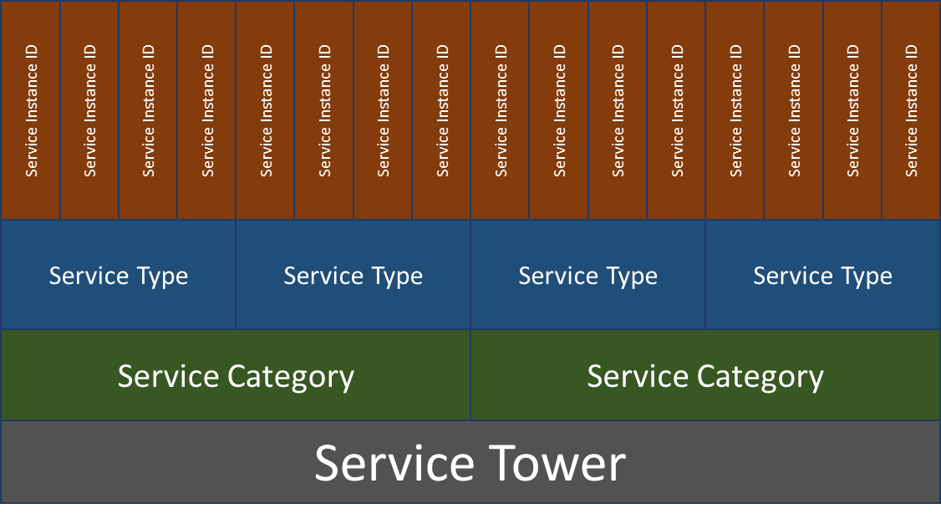
Figure 1 Service Tower Composition
Each layer of the hierarchy can be expressed as being made up of Modules, Components and Elements, as illustrated in Figure 2 below, which are referred to as Building Blocks. As each layer is comprised of the layers above, the lower layer Building Blocks can be considered supersets of the above layers Building Blocks. Another way of thinking of this is that you can define layers up the hierarchy by removing building blocks.
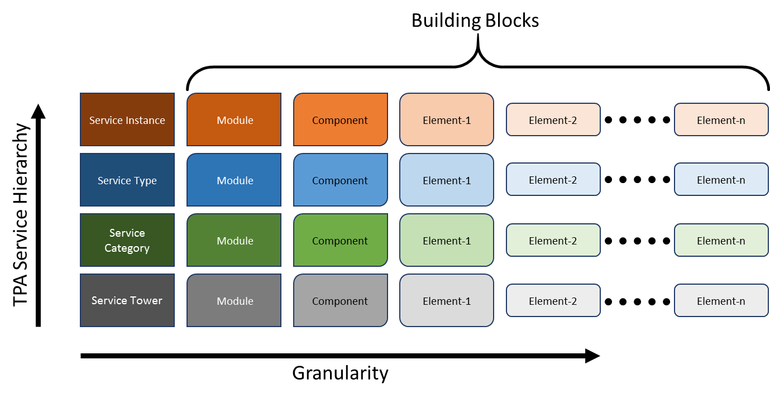
Figure 2 TPA Service Hierarchy and Granularity
By configuring permutations of the Building Blocks at each layer, different variations of Service Towers, Service Categories, Service Types and ultimately Service Instances can be defined.
Figure 3 shows examples of how each layer could vary by the configuration of Modules and Components. These examples may be extrapolated to include Elements as well.
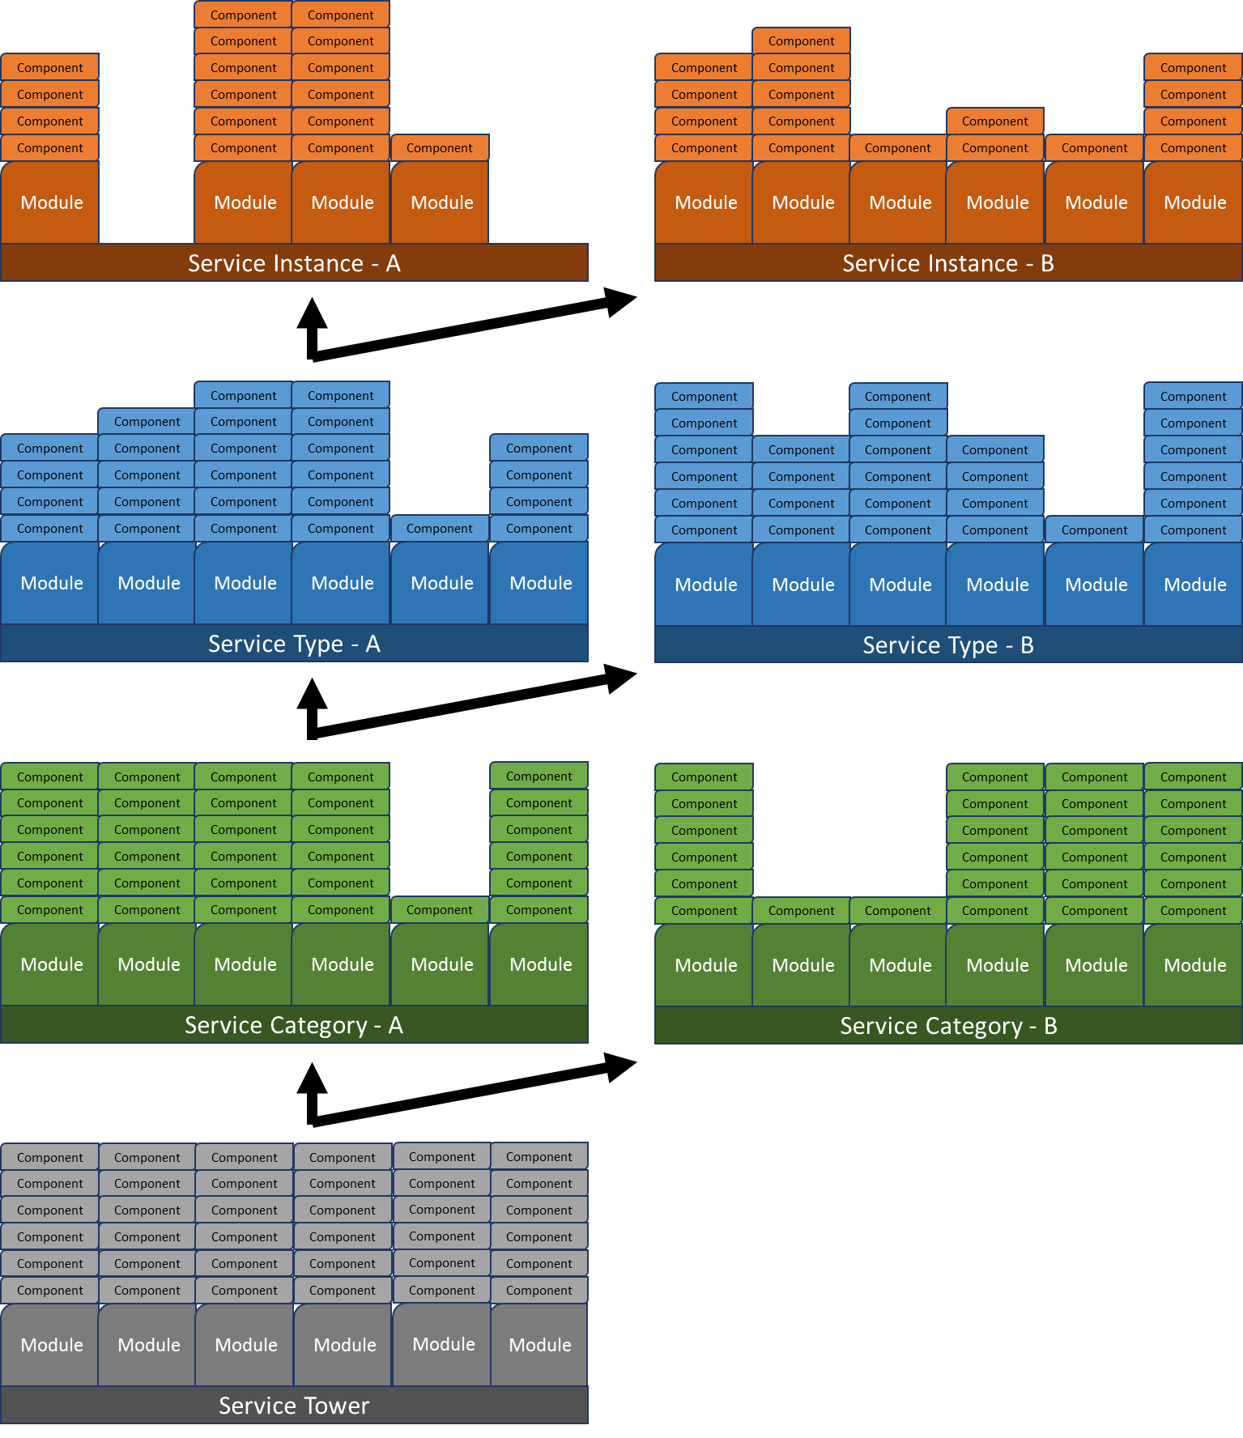
Figure 3 Service Tower Composition Examples
Figure 4 below shows the current Telecommunication Purchasing Arrangements (TPA) Service Towers and Service Categories with Network Applications, the focus of this document, highlighted.
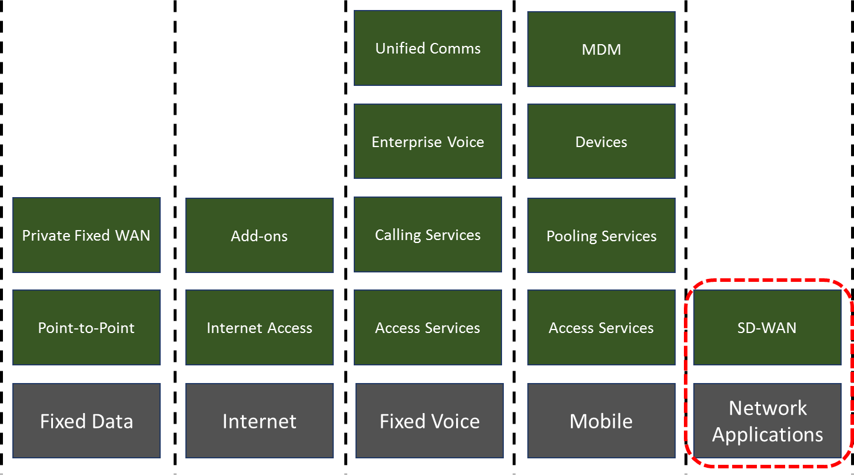
Figure 4 Current TPA Service Towers and Service Categories
Figure 5 below shows the building blocks of the Network Applications Service Tower. Permutations of these building blocks results in the configuration of the Service Categories.

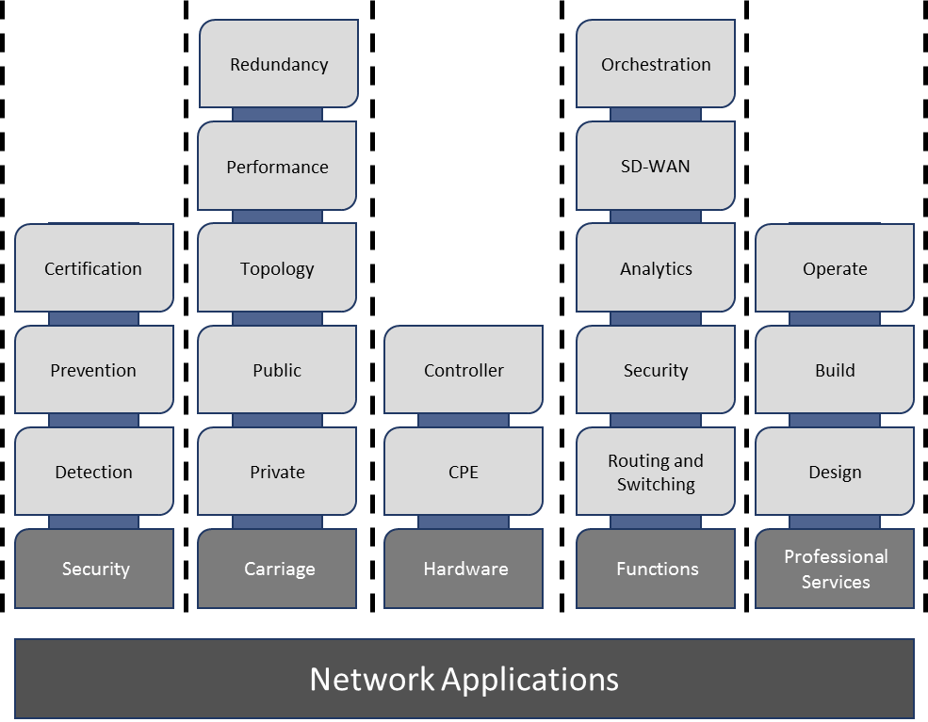
Figure 5 Network Applications Composition

Service Category Description – SD-WAN
Software Defined Wide Area Network (SD-WAN) is a Service Category under the Network Application Service Tower, a new service tower within the TPA framework. SD-WAN describes services that utilise overlay, or over-the-top, technologies to provide connectivity to one or more Customer locations. Since these services can sit on top of multiple, disparate services they can offer improved service delivery capabilities over traditional Fixed Data services.
SD-WAN Services are fundamentally modular, allowing Customers to construct the service that best fits their requirements. Although, as shown in Service Type – SD-WANaaS various combinations have been selected to build the SD-WANaaS service catalogue.
The building blocks, or modules, of SD-WAN are;
- Security
- Carriage (may be referred to as underlying carriage)
- Hardware
- Functions
- Professional Services
Within each module are components which can be included, or excluded, in various configurations to construct a set of unique SD-WAN Services, as illustrated in Figure 6 below.
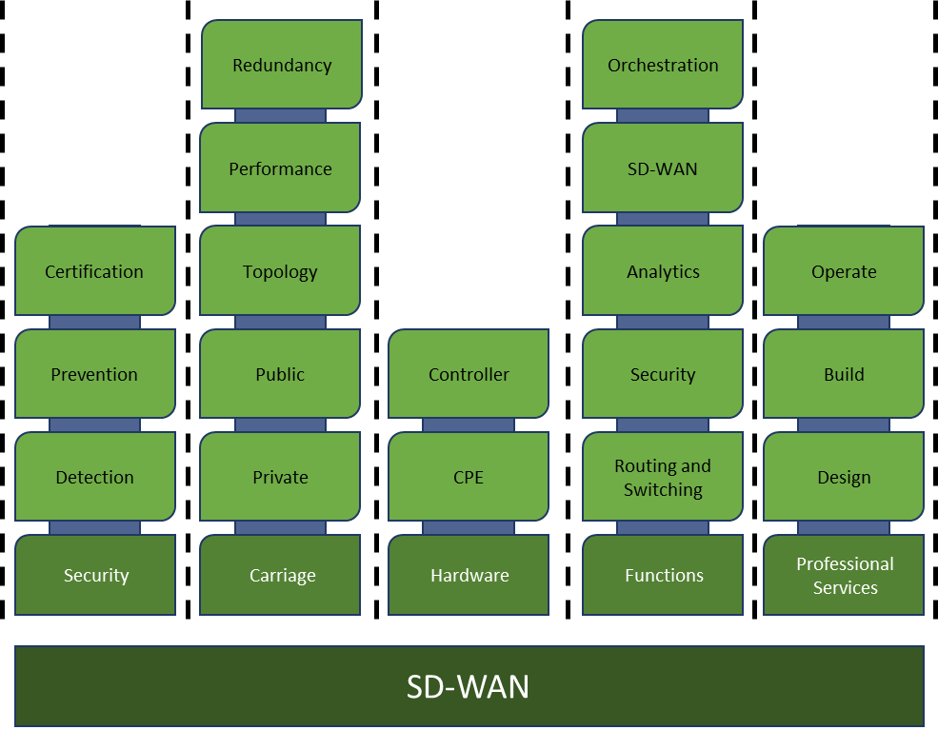
Figure 6 SD-WAN Modules and Components

Service Category Modules and Components
Due to the flexible nature of Network Applications, each of the comprising modules can have more than one option or configuration. Customers will define which modules and components apply to their services.

Security
Overview | Security is the policies and practices adopted to protect the usability and integrity of the service. Given the centralised control and the use of publicly connected carriage, security is arguably the most important aspect of the service.  Security covers the following areas;  - Detection  - Prevention  - Certification
Variations | Figure 7 below shows the building blocks of security.  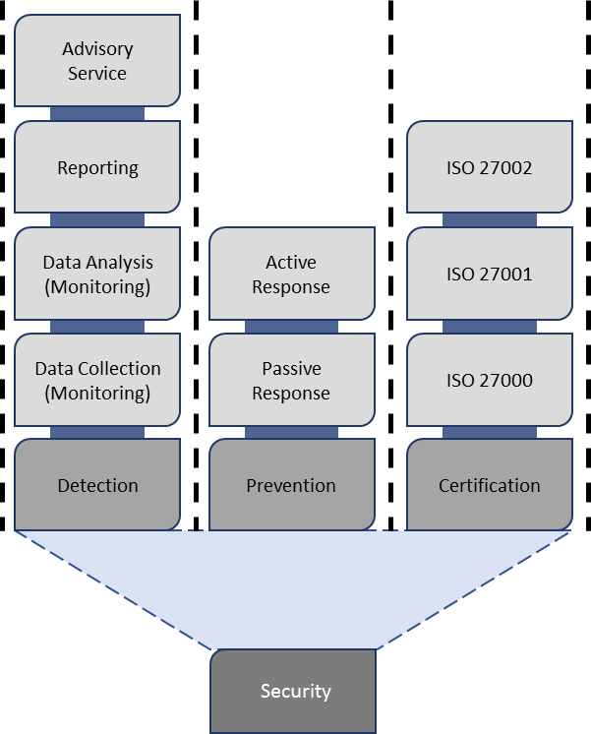  Figure 7 Security Modules and Components

Carriage
Overview | Carriage, or underlying carriage in the context of SD-WANaaS, is the physical infrastructure, above which an overlay network or service is built. It is responsible for the delivery of packets across networks  The Underlying Carriage can vary in the following ways;  - Capacity  - Performance – latency, jitter, packet loss  - Redundancy – single link, diverse links, diverse carriers, diverse mediums  - Assurance type – Private Data Network (private networks such as MPLS), Public Data Network (4G, Internet, etc.)  - Topology  The underlying carriage for an example SD-WANaaS service is shown in Figure 8 below. The black and purple represent the underlying carriage, while the green dotted line represents an overlay tunnel.  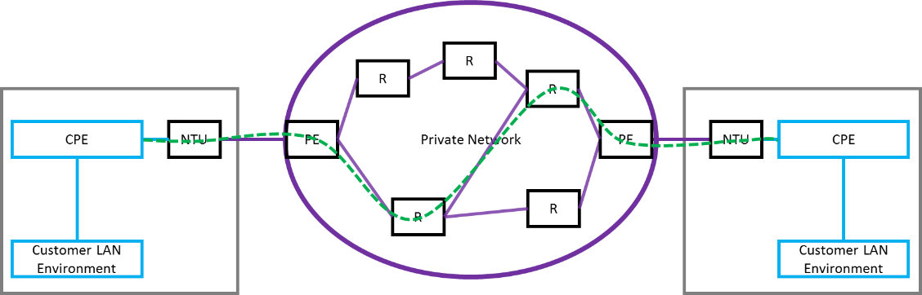  Figure 8 Underlay Network and Overlay Service  Customers may opt to consume an Overlay Network Service as a full package where underlying carriage is included. Alternatively, the Customer may opt to utilise their own underlying carriage (existing or otherwise) as part of the service.  The key feature of Underlying Carriage is that it is flexible in terms of its configuration. The Customer can choose from many permutations of multiple links and Private Data Network or Public Data Network carriage. It is expected that the Customer will choose the underlay configuration and bandwidth(s) to meet their requirements, however this service may evolve to have an option for the Customer to define applications and overlay characteristics and allow the Service Provider to choose the appropriate underlay configuration and bandwidth(s).
Variations | Figure 9 below shows the Module and Component breakdown of Carriage.  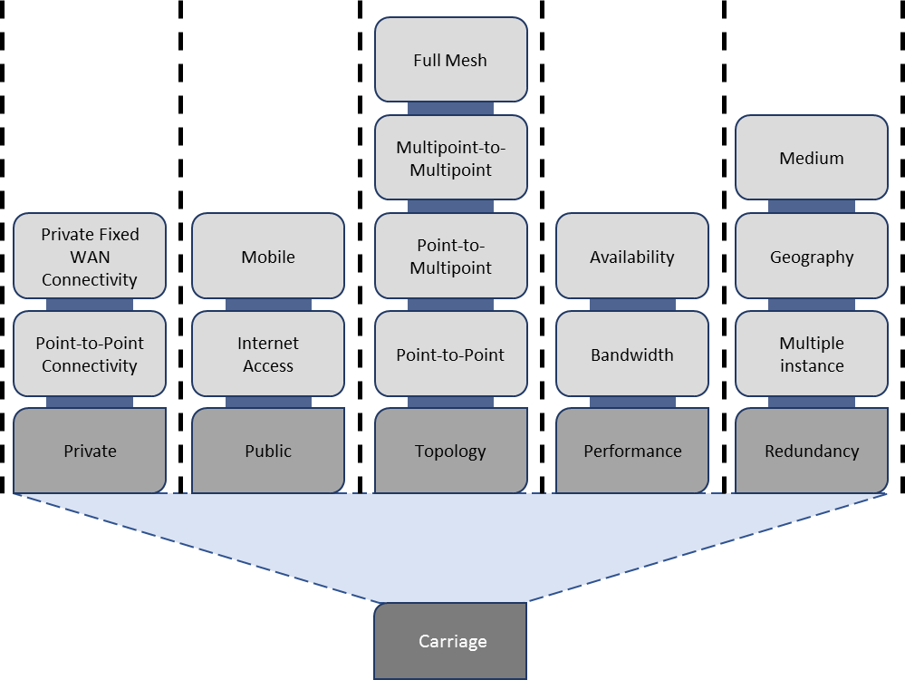  Figure 9 Carriage Modules and Components  For simplicity, the following example figures will show the underlying carriage configurations for a single location.  Redundancy and Assurance Type Configurations  - Single carriage; 1x private network uplink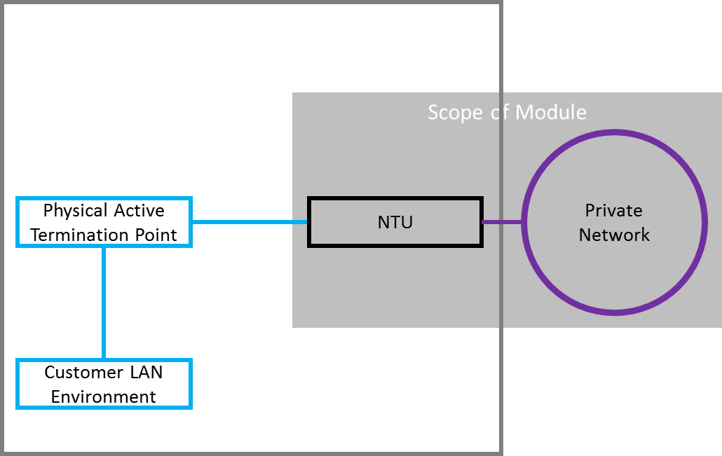  Figure 10 Single Private Data Network Carriage  - Single carriage; 1x Internet uplink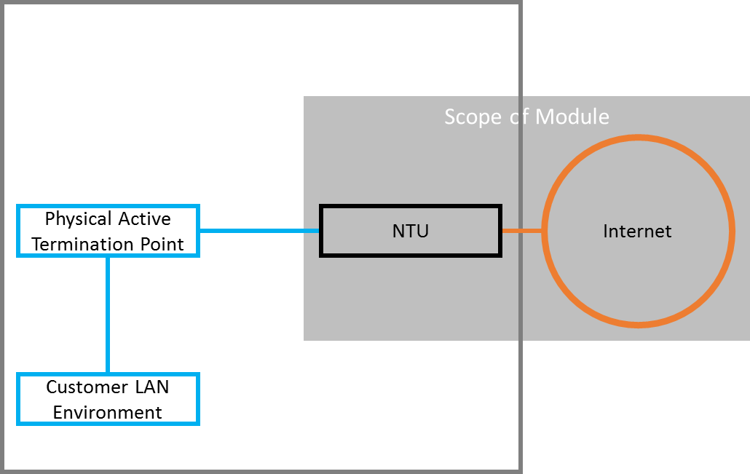  Figure 11 Single Public Data Network Carriage  - Dual carriage; 1x private network & 1x Internet uplinks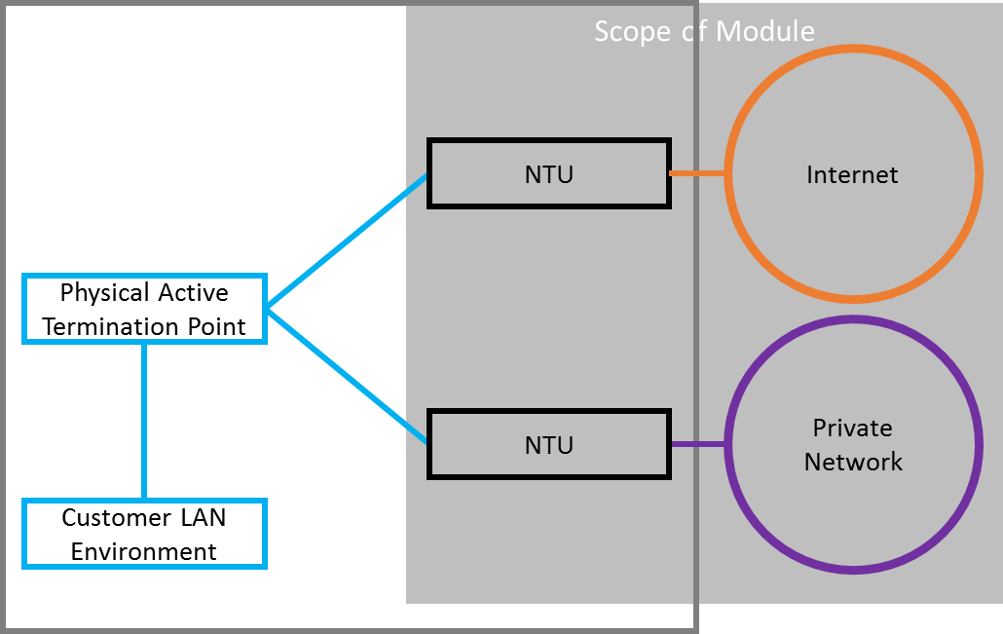  Figure 12 Dual Carriage - Private Data Network and Public Data Network  - Dual carriage; 2x private network uplinks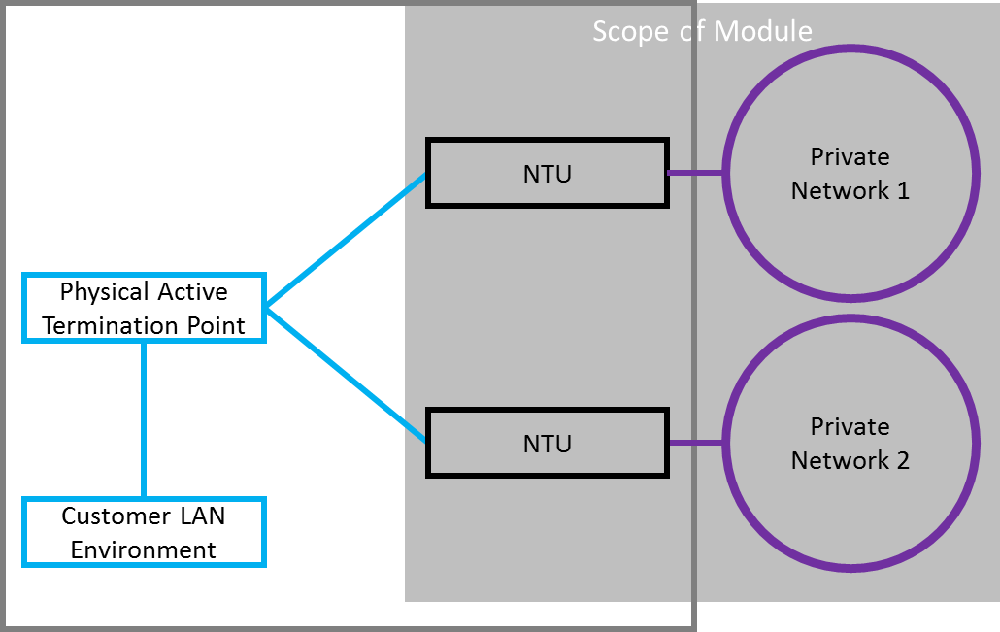  Figure 13 Dual Private Data Network Carriage  - Dual carriage; 2x Internet uplinks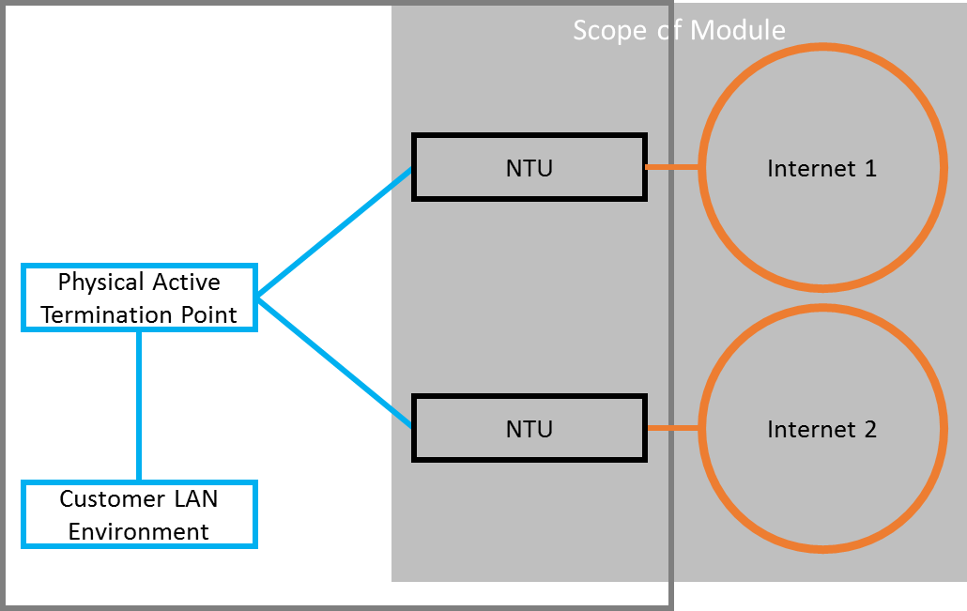  Figure 14 Dual Public Data Network Carriage  - Multi-carriage; n x private network & n x Internet uplinks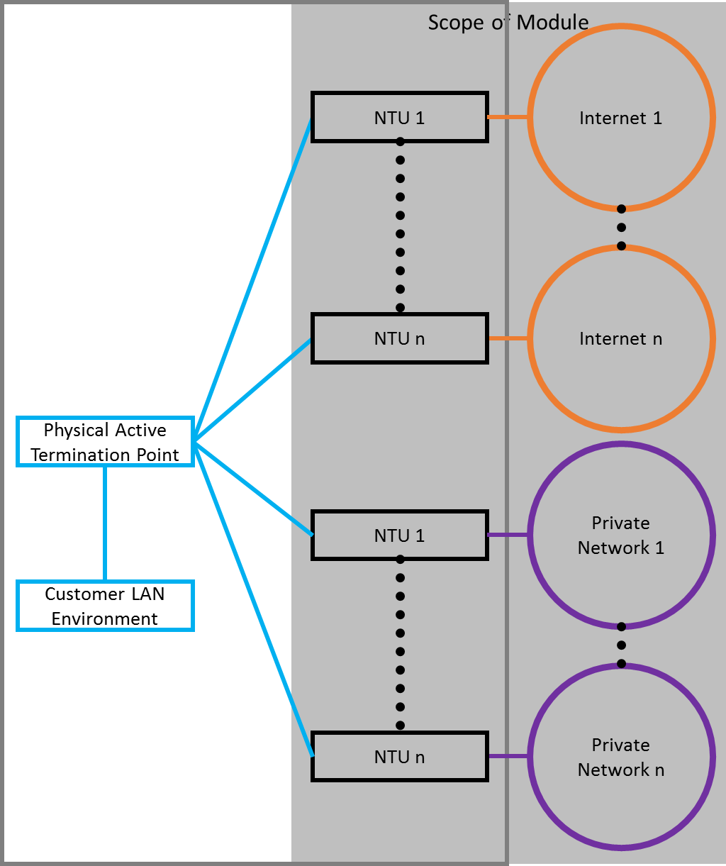  Figure 15 Multi-carriage  Underlying Carriage Source  There are two variants for the sourcing of underlying carriage;  - Bring your own (BYO); whereby the Customer uses existing or new carriage that they sourced as the underlay  - Provider sourced; this is where the Customer requires the Provider to source the underlay carriage whether it be from the Provider’s own network or from a 3rd party.

Hardware - CPE
Overview | An active termination point (as referenced in Figure 18, Figure 19 and Figure 20 below) for SD-WANaaS is referred to as a CPE (Customer Premises Equipment). This device is typically located at a Customer’s site and has two main roles;  - The router to interface between the customer LAN environment and WAN uplink(s);  - The logical termination point(s) for the overlay network.  Figure 16 below shows the building blocks of the Hardware module, with the CPE component highlighted.  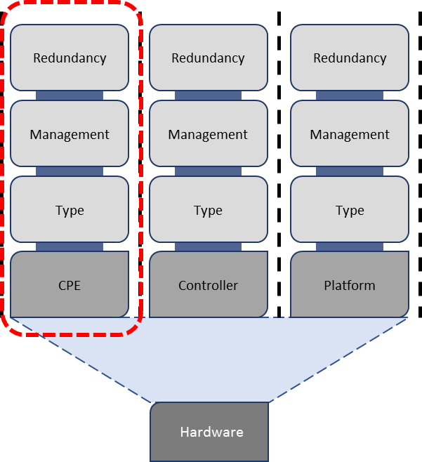  Figure 16 Hardware Components and Elements  There are three main variants for the CPE component; physical CPE, virtualised CPE and cloud-based CPE, as illustrated in Figure 17 below.
Variations | 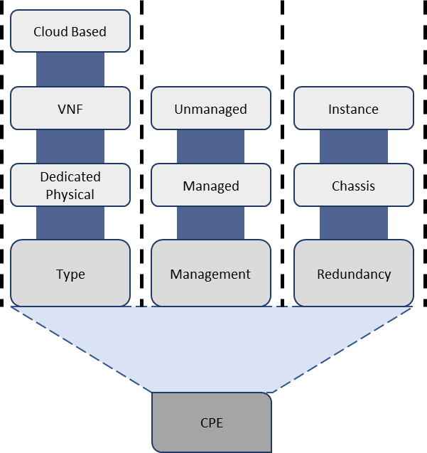  Figure 17 CPE Elements  - Physical CPE- a device that is dedicated to performing the networking functionality  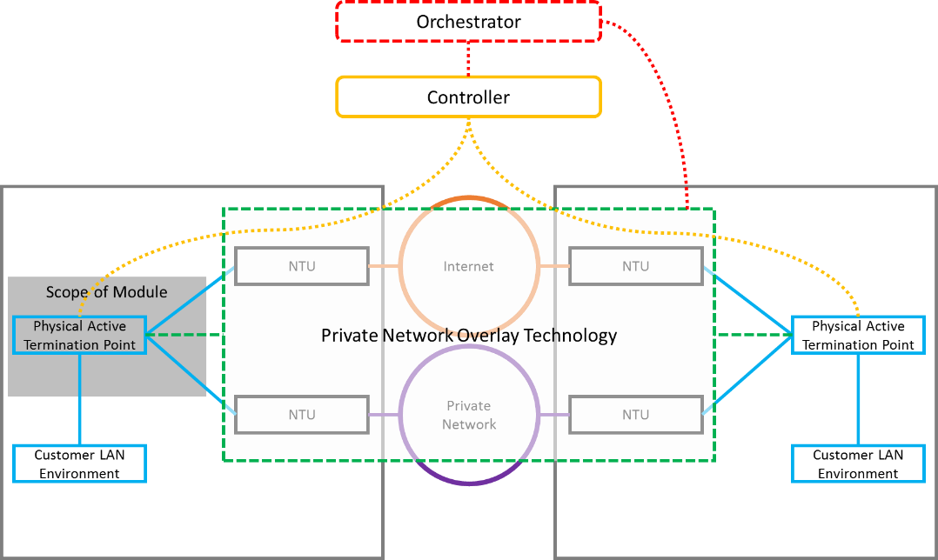  Figure 18 Physical CPE  - Virtualised CPE- a virtualised instance of CPE that is hosted on a device that can host one or more virtual network functions  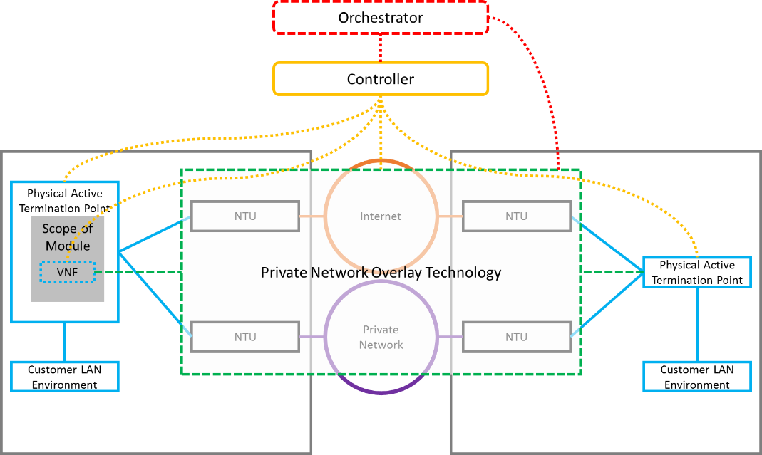  Figure 19 Virtualised CPE  - Cloud-based CPE- a special case of a virtualised CPE that is hosted in a cloud environment. It is typically used to facilitate direct access to a Customer’s cloud environment.  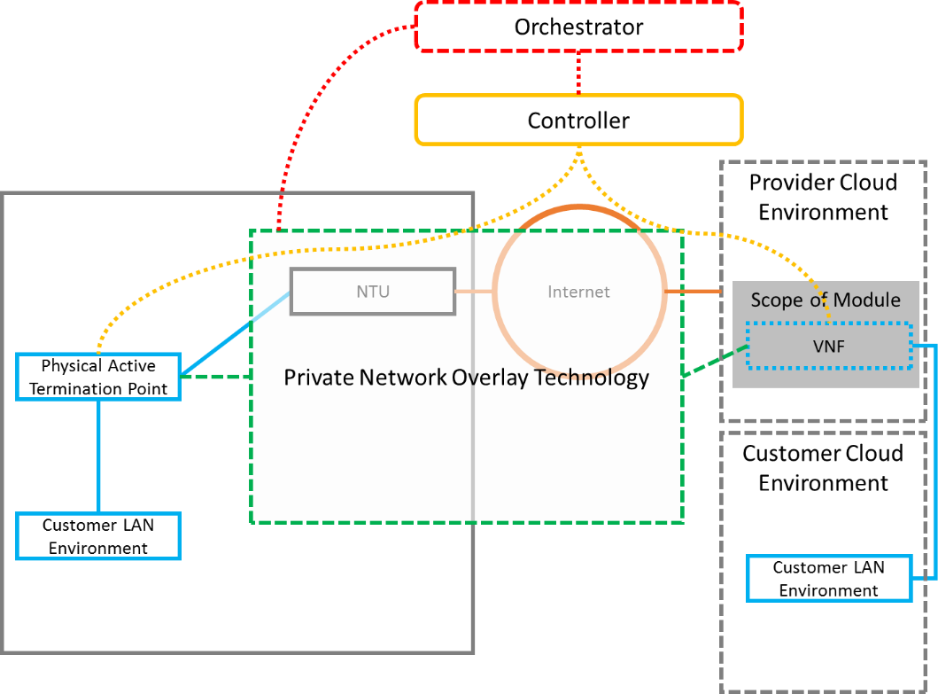  Figure 20 Cloud-based CPE

Hardware - Controller
Overview | The controller provides device management, be they physical or virtual. This includes, but is not limited to, provisioning (configuration and activation), address management, and policy management.  This is different to the Orchestration function, which relates to application layer services such as network and service orchestration. Figure 21 below shows the three levels of hierarchy involved in the control and orchestration of an Overlay Network Service environment.  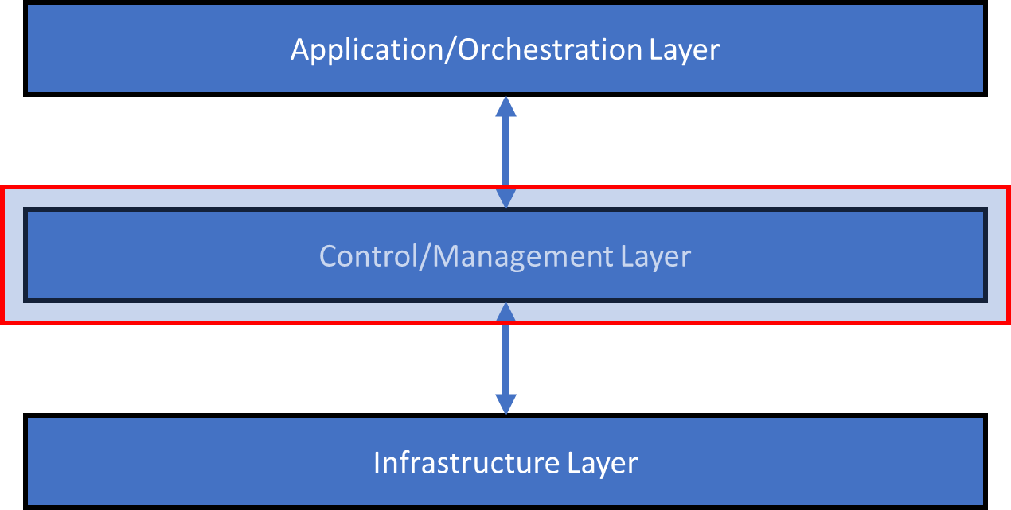  Figure 21 Hierarchy of Overlay Network Service Orchestration, Control and Management
Variations | Figure 22 below shows the building blocks of the Hardware module, with the Controller component highlighted.  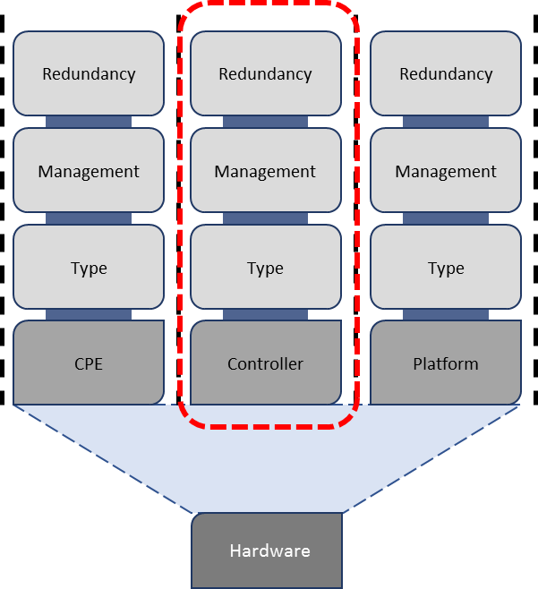  Figure 22 Hardware Components and Elements  There are three main variants for the Controller component; physical controller, virtualised controller and cloud-based controller, as illustrated in Figure 23 below.  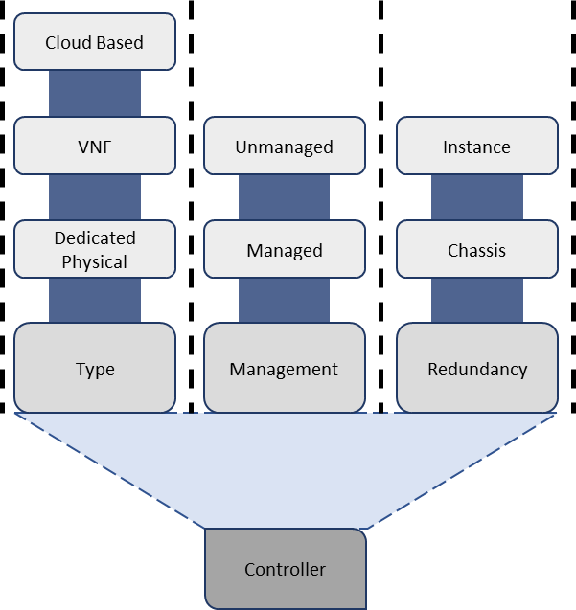  Figure 23 Controller Elements  - Physical/Dedicated Controller- a unit that is dedicated to performing the control plane functionality.  - Virtualised Controller - a virtualised instance of the controller that is hosted on a device that can host one or more controllers or virtual machines.  - Cloud-based Controller- a special case of a virtualised controller that is hosted in a cloud environment.

Functions
Overview | Overlay Network Service functions refer to the base and over-the-top functions that Customers will be looking to employ to achieve their business outcomes. There are two types of Functions; Network Function and Service Function.  Figure 24 below shows the Components and Elements of the Functions Module.
Variations | 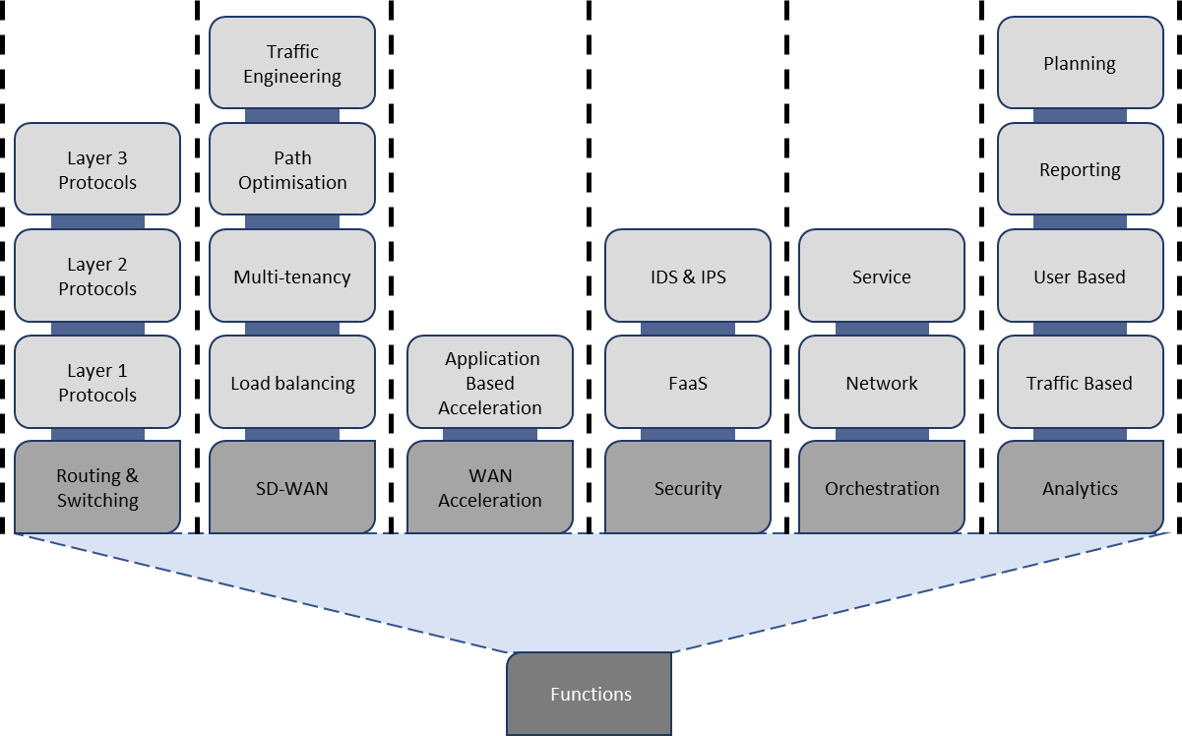  Figure 24 Functions Components and Elements  - Routing and Switching – up to layer 3 connectivity to the underlying WAN carriage(s) and the Customer LAN environment(s). This base routing function is analogous with the connectivity given by CPEs for traditional layer 3 services.  - SD-WAN – the grouping of advanced networking functionality. This includes, but is not limited to, advanced routing, deep packet inspection, disaggregated network and control planes, etc.  - WAN Acceleration – the category of technologies or techniques used to optimise the efficiency of data flow across a WAN.  - Security – separate from the Security module, this refers to the network security functionality that can be added to a service.  - Orchestration – the function that provides the ability to coordinate and automate changes to CPEs to support applications and services.  - Analytics – at its core this is the observation, examination and reporting of usage, traffic and/or user patterns. This may be extended to include planning and optimisation.

Professional Services
Overview | Professional Services refers to the set of services that a Customer may require to start-up and run their service(s). At a high level, Professional Services is made up of the designing, building and operation of the Customer’s Service(s).  Figure 25 below shows the Components and Elements of the Professional Services Module.
Variations | 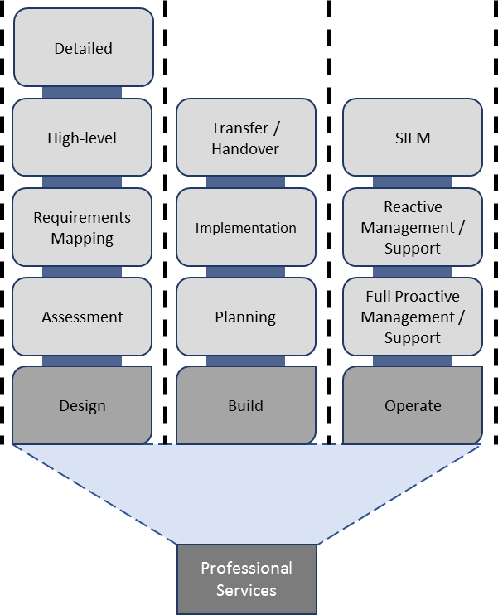  Figure 25 Professional Services Components and Elements  - Design – the iterative process aimed at ensuring that the network or service meets the needs of the Customer.  - Build – the configuration and construction of the network or service that meets the needs of the Customer.  - Operate – the running of the network or service to the specification that meets the needs of the Customer.

Service Type – SD-WANaaS
SD-WANaaS is a Service Type within the SD-WAN Service Category. Although the modular style of Network Applications allows for there to be many variants of the service, the focus of this service category is SD-WAN as-a-Service i.e. where most, if not all components are provided to the Customer as a bundled service by a single Service Provider. However, there are options for carriage to be provided by a 3rd party (or the customer) where the SD-WAN provider manages the carriage for the customer.

SD-WANaaS – Choose Your Carriage
Service Overview | This Service provides a virtual overlay network that enables application aware, policy driven and orchestrated connectivity between two or more customer locations.  This services key attribute is its ability to effectively leverage multiple, disparate underlying carriage services, allowing greater flexibility, agility and value for money.  Using the SD-WANaaS building blocks, this variant of SD-WANaaS is expressed as follows in Figure 26.  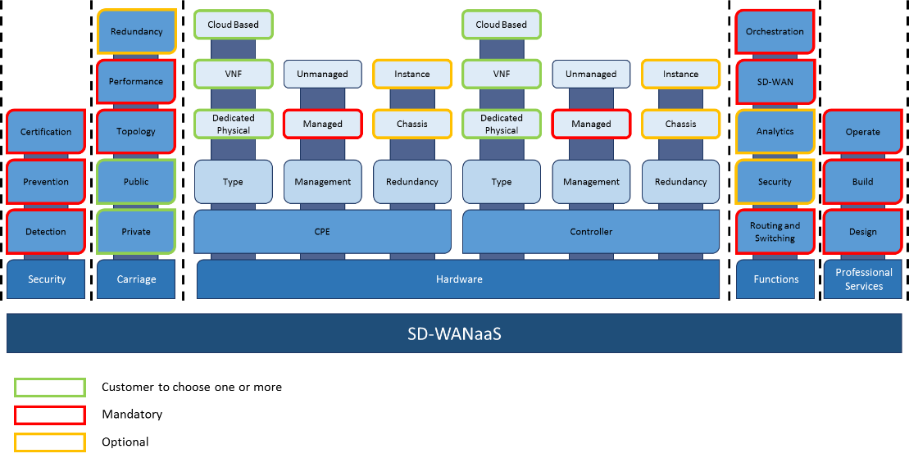  Figure 26 SD-WANaaS Fully Provided – Modules, Components and Elements  Figure 27 below is an example of an SD-WANaaS configuration between two Customer locations. Other configurations exist, such as point-to-multi-point in hub and spoke and full mesh topologies. The scope highlighted below is for a single site only, and does not seek to show the end-to-end scope.  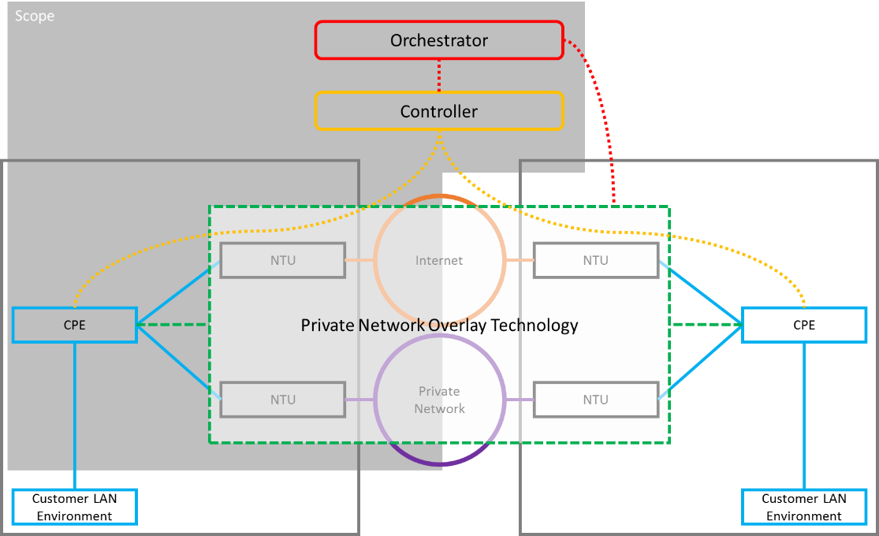  Figure 27: SD-WANaaS demarcation and scope  The service will also be delivered with Common Services as per the Common Services specification.  Depending on the Service Management Level chosen by the Customer, the Service Provider is responsible for determining if there are any faults with the service and resolving them.
Base Service Deliverables | The Base Service will provide:  - Underlying carriage; one or more underlying carriage for each location in the SD-WAN fabric. This component will be priced separately, leveraging the Fixed Data, Internet and Mobile Service Towers. Customers will choose their own underlying carriage which may be provided by the same entity that provides the SD-WAN overlay, or some other 3rd party (BYO).  - CPE; physical or virtual (cloud-based or hosted on-premise)  - Base Routing; base routing protocols to enable usage of the underlay network(s) and provide connectivity towards the Customer LAN environment  - SD-WAN functionality; multiple carriage underlay, policy or application-based routing, WAN hardening, encryption  - Orchestration; provisioning, configuration, operational management, reporting (network and service)  - Professional Services; the design, build and operation of the service
Optional Service Deliverables | In addition to the Base Services, there may be optional features such as:  - An option for self-service monitoring or management (configuration change) of the service.  - A range of options for SD-WAN functions  - Advanced security such as intrusion detection systems (IDS), intrusion prevention systems (IPS) and URL filtering  - Deep packet inspection (DPI)

Price Book

Overview
For pricing, components can be grouped into three groups, as per below. Each group consist of components that are dependent on each other to be able to be priced. Unique variants within each group are constructed by choosing one of each of the elements.

Group # | Name | Pricing Components
1 | SD-WANaaS - Overlay | Overlay availability  # BYO Links  Location
2 | SD-WANaaS - CPE | CPE Type  CPE Throughput
3 | SD-WANaaS - Controller | Controller Type  # of Supported NEs  Controller Redundancy
Table 1 Price Book Groupings
It should be noted that if a component only has one option (e.g. Full Proactive Management under Service Management Level) then it will not be expressed in the Price Book.

Underlying Carriage
Note: Underlying carriage is not included in this Price Book.
Customers will choose the underlying carriage from the existing Service Towers of Fixed Data, Internet and/or Mobile.
Customers will be able to choose the underlying carriage from any Service Provider(s), regardless of the Service Provider providing the SD-WAN overlay. The costs associated with an SD-WAN overlay provider managing underlying carriage from other service providers is captured in "SD-WANaaS - Overlay".

Service Construction
To construct a unique service, or price point, customers will choose one possible option from each group, with the price for the full service being the sum of the prices for each option chosen, as per below:

$$Service Price= \left(Overlay Cost\right)+\left(CPE Cost\right)+\left(Controller Cost\right)$$

Note that the overlay cost is $0 where no BYO links are utilised.

SD-WANaaS will typically be consumed as a network, as opposed to a single service, and in most scenarios a Customer will only require the Controller to be defined once per network instance whereas the Overlay and CPE may need to be defined multiple times, dependent on the number of sites in a network. Therefore, the following equation describes the typical total cost for a network service excluding carriage (which is BYO in this example):

$$Service Price= \left({Overlay Cost}_{1}+{Overlay Cost}_{2}+{Overlay Cost}_{3}+{Overlay Cost}_{4}\right)+\left({CPE Cost}_{1}+{CPE Cost}_{2}+{CPE Cost}_{3}++{CPE Cost}_{4}\right)+\left(Controller Cost\right)$$

Response Scenarios
A single service can be made up of three parts: "SD-WANaaS - Overlay", "SD-WANaaS - CPE" and "SD-WANaaS - Controller". However, a respondent may not choose to price a service using all three parts, instead choosing to bundle the cost into one of the other parts. This choice is generally driven by the licencing arrangements for the underlying solution.
Below is an exhaustive list of valid scenarios:

Scenario 1 - Pricing responses in all three tabs
CPE, Controller and Overlay management are each priced separately. For a customer to 'price up' an SD-WANaaS offering for this scenario they need to choose a single line item from all three tabs.

Scenario 2 - Pricing Responses in "SD-WANaaS - Overlay" and "SD-WANaaS - CPE" only
CPE and Controller pricing is bundled together. The Overlay management is priced separately. For a customer to 'price up' an SD-WANaaS offering for this scenario they need to choose a single line item from each of these two tabs.

Scenario 3 - Pricing responses in "SD-WANaaS - CPE" and "SD-WANaaS - Controller" only
CPE and Controller are priced separately. The cost of Overlay management is not impacted by the mix of 3rd party provided, or respondent provided underlying carriage. For a customer to 'price up' an SD-WANaaS offering for this scenario they need to choose a single line item from each of these two tabs.

Scenario 4 - Pricing Responses in "SD-WANaaS - CPE" only
CPE and Controller pricing is bundled together. The cost of Overlay management is not impacted by the mix of 3rd party provided, or respondent provided underlying carriage. For a customer to 'price up' an SD-WANaaS offering for this scenario they need to choose a single line item from this tab only.

Glossary
Term or short form | Long-form | Definition
aaS | as-a-Service | An item, or grouping of items, made available to a customer as a service
Active Termination |  | Where the Service Provider provide a device that terminates the service at a site and enables end-to-end management.
ADSL | Asymmetric Digital Subscriber Line
APN | Access Point Name | A gateway between a mobile network and another network, such as the Internet or a Private WAN.
bps or bit/s | Bits per second
BYO | Bring your own
CAB | Change Advisory Board
Circuit |  | For data connections, a circuit a path that data transverses between two points. A circuit is a component of a Service.
CMS | Configuration Management System
Contract Authority |  | The central entity that is accountable and responsible for the Head Agreements of the TPAs
CoS | Class of Service
 |  | TPA Release Version
CSI | Continual Service Improvement
Customer |  | NSW Government Agency, or any organisation procuring services from the Service Catalogues.
CPE | Customer Premise Equipment | A device that is used by Service Providers to terminate services at a site.
Customer Termination Device |  | A Customer device that is connected to the Provider's equipment
DHCP | Dynamic Host Control Protocol
DISS | Digital Information Security Strategy
DoS (or DDoS) | Denial of service (or distributed denial of service) | An attack that attempts to make a service unavailable by overwhelming it with traffic from multiple sources.
DWDM | Dense Wavelength Division Multiplexing
Error |  | A design flaw or malfunction that causes a failure of one or more IT services or other configuration items.
Event |  | A change of state that has significance for the management of a service.
Gateway device |  | A layer 3 device at a site that acts as the site’s router, to transmit packets to the WAN. Host devices have a gateway device configured, typically via DHCP.
Gbps or Gbit/s | Giga (billion) bits per second
Grey Area Diagnostics |  | The process to proactively diagnose in-scope services and interconnections to help identify the cause of an incident or problem. The result is to identify that the cause of the incident or problem:  - Is caused by in-scope services  - Is not caused by in-scope services  - Could be caused by in-scope services, and further diagnostics are required
ICT | Information and Communications Technology
ICT Risk Management |  | Information Communication Technology (ICT). The NSW Digital Information Security Policy mandates a risk-based approach to securing information, based on the ISO 27001 standard. DFSI has implemented a framework in line with the policy, with ICT risks being managed through an Information Security Management System (ISMS).
Incident |  | An unplanned interruption to a service or a reduction in the Quality of a service. Failure of a configuration Item that has not yet impacted service is also an Incident.
IP | Internet Protocol
IPSLA | Internet Protocol Service Level Agreement | Cisco IOS feature that allows for the collection of network performance information.
ISM | Information Security Management
ISMS | Information Security Management System
ISO | International Standards Organisation
ITSM | IT Service Management
IVR | Interactive Voice Response
kbps or kbit/s | Kilo (thousand) bits per second
Known Error |  | A Problem that has a documented root cause and workaround.
Location, Site |  | A Customer site or location is a place where services are to be delivered. Depending on the service, this may not necessarily be a physical building.
MACD | Move, Add, Change or Delete
MAN | Metropolitan Area Network
Mbps or Mbit/s | Mega (million) bits per second
MNO | Mobile Network Operator | Provider of wireless/mobile communications services that owns or controls all the elements necessary to sell and deliver services to an end user, e.g. radio spectrum, wireless network infrastructure, back haul, billing, customer care, provisioning systems and repair capabilities.
MVNO | Mobile Network Operator | Provider of wireless/mobile communications services that does not own the wireless network infrastructure over which it provides services to its customers. Instead they enter a business agreement with an MNO to obtain bulk access to network services at wholesale rates. They do have their own customer service, billing systems, marketing, and sales personnel.
MPLS | Multi-Protocol Label Switching
MTU | Maximum Transmission Unit
NBN | National Broadband Network
NBN Co |  | The entity responsible for the design, build and operation of the NBN
NFV | Network Function Virtualisation
NIVR | Network Interactive Voice Response
OADM | Optical Add-Drop Multiplexer
Operational Risk |  | Risks associated with business-as-usual activities at the Division / Business Unit / Related Entity level that is normally managed within that area, unless the level of risk requires a review by the DFSI Executive and/or Secretary.
OSS | Operational Support System
OTT | Over-the-top
Passive Termination |  | Where the Service provider provides a physical termination point which can’t be monitored.
PE | Provider Edge
Peering |  | The exchange of data directly between Content Providers and Customers, rather than via the Internet.
Performance |  | A measure of what is achieved or delivered by a system, person, team, process or service
POI | Point of Interconnect
POP | Point of Presence
Priority |  | The value given to an Incident, Problem or Change to indicate its relative importance in order to ensure the timeframe within which action, such as Response and Resolution, is required.
Private Data Network |  | A network or networks that utilises private infrastructure to deliver physically or logically private services
Problem |  | A cause of one or more Incidents. The cause is not usually known at the time a Problem Record is created, and the Problem Management Process is responsible for further investigation.
Public Data Network |  | A network or networks that utilises publicly available, shared infrastructure such as mobile networks or the Internet
Public Holidays |  | All NSW public holidays as gazetted, except for Bank Holidays specific to only banks and financial institutions as per the Retail Act.
QoS | Quality of Service
RACI | Responsible, Accountable, Contributor, Informed
Resolver Group |  | Specialised groups that have the knowledge and skill to solve an Incident or Problem.
R-OADM | Reconfigurable Optical Add-Drop Multiplexer
Root Cause |  | The underlying or original cause of an incident or problem.
RSP | Retail Service Provider
Sandboxing |  | A security mechanism for separating untested or untrusted programs or code to mitigate system failures or software vulnerabilities from spreading.
Satellite |  | Satellite based connectivity to deliver NBN connectivity
SDN | Software Defined Network
SD-WAN | Software Defined Wide Area Network
SD-WANaaS | SD-WAN-as-a-Service
Service Window |  | Service window is defined as the timeframe within which service availability and service management (incident response, incident resolve) are measured and managed.
Significant Event |  | This is an event that materially impacts a Customer, and is likely to be a P1 or P2.
SIP | Session Initiation Protocol.
SLA | Service Level Agreement
SoR | Statement of Requirements
TDM | Time Division Multiplexing
TPA | Telecommunications Purchasing Arrangements
User |  | A person who uses a service on a day-to-day basis.
VIP | People with critical roles within an organisation, and identified to Service Providers.
VNF | Virtual Network Function
VPN | Virtual Private Network
WAN | Wide Area Network
WoG or WofG | Who of government | All Clusters and Agencies within the NSW Government.

Strategic Sourcing | ICT / Digital Sourcing | Department of Customer Service

Address: Level 23, McKell Building, 2-24 Rawson Place, Sydney NSW 2000

E-mail: Strategic.Sourcing@customerservice.nsw.gov.au

