Getting ready to use the Self Service Portal (SSP) – your Checklist

The Self-Service Portal has been developed to enable each agency to apply for their Feedback Assist solution. Prior to using the SSP, please complete the checklist below and send your information into the Implementation Team for verification. Once you are ready to go, we will send your log in details to the SSP.
Please provide the Name and Email Address of the person who will complete the SSP:
Email:
Name:

Task No | Activity | Your Information | Suggestions/Examples | Completed
 | Determine if you are going to use the Feedback Assist solution to manage feedback or whether you will be integrating to an existing Complaint Management System that is currently in use. | Feedback Assist solution  Existing Complaint Management  System
 | Identify which websites the Feedback Assist widget will appear on.  List the URL/s – you may have many websites feeding into the same queue. |  | www.records.nsw.gov.au
 | Identify all website owners and whether it is managed Internally (I) or Externally (E) |  | Knowing how long it will take to load the code onto your website will help you plan your Go-live date.
 | Identify if the website has a staging or testing environment and provide URL. |  | Only provide one test environment
 | What is your current website traffic per month? |  | Please provide number of visits per month on your website e.g. 5000
 | What is your Agency Name? |  | State Archives & Records
 | Determine the Agency (Short) Name. |  | SARA or State Records.  This will be used to create your email:  sara@yourfeedback.nsw.gov.au
 | Advise your ‘Go-Live’ date |  | Estimated date you will aim to load the code onto your website.
 | If your agency is going to use the Feedback Assist solution, list all staff that will require access to the system (this can change at the time you complete the SSP)  Provide their name and email address.  If your agency will be using an existing Complaint Management System, please provide the name of the system instead. |  | If this space is not big enough for the number of staff requiring access, just keep a separate list.  It is important that you know this information at the time of using the Self Service Portal.  You must have at least one ‘Manager’
Identify your contact telephone number/s
You can have up to 4 phone numbers displayed.
 | Does your agency have Facebook?  If so, do you want the Facebook link to be displayed on the Feedback Assist widget? |  | Yes/No  Please add the URL of your Facebook page
 | Does your agency have Twitter?  If so, do you want the Twitter link to be displayed on the Feedback Assist widget? |  | Yes/No  Please provide your twitter handle name @ and URL
 | Is your agency set up to support Live Chat?  If so, do you want to give customers the option to use this function on the Feedback Assist widget? |  | Yes/No  Please note:  Staff listed in Q9 will be able to use this function to Live Chat with customers. More information below.
 | The third question on the Feedback Assist widget is “Is there anything you would like to add?”  You can customise this question if you require. If you want to use the default, leave this as is, otherwise record your proposed question here ……….. |  | Be aware that the question you nominate needs to be relevant to both Compliments and Complaints.

 | The Location field is optional.  Advise if you want to use it.  The default question is “Where did this happen?” If you want to use the default, leave this as is, otherwise record your proposed question here ……….. |  | This field uses Google maps and is only useful if you need to know where something occurred.
 | What is your SLA for acknowledging a complaint? |  | Check with your Department’s Complaint Handling Policy
 | If the customer provides an email address, the system will send them an email showing we have received their feedback.  There is an option to add another paragraph to this email, if required. If you want to add a paragraph, record your proposed sentence here……… |  | If your matter is an emergency, please contact 000  If your case is about a trader rather than about our service, please use the form contained in the following link xxxx
 | Do you require Knowledge Articles for your widget? (please find more details below) |  | Yes/No?  These knowledge articles will appear on the widget when particular keywords are entered by the citizens
 | Does the staff listed in Q9 would like to receive email notification when a customer submits new feedback to your queue? |  | Yes/No

Once you have filled out the boxes above, please save this document and then email it to the support@onegov.nsw.gov.au
The Implementation Team will provide you with the log on details to the Self-Service Portal.

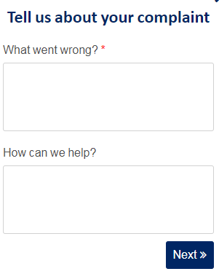
The first screen of Feedback Assist will remain the same on all government websites.
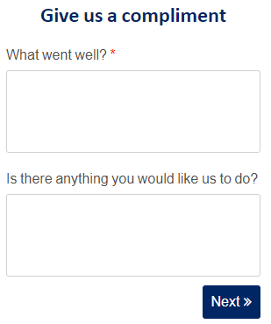

There are some aspects of the second screen that can be customised:
The third question default is “Is there anything you would like to add?” If you choose to customise the question, it;
- needs to be phrased as a question;
- cannot be much longer that what is displayed as the default;
- needs to be relevant for both Compliments & Complaints
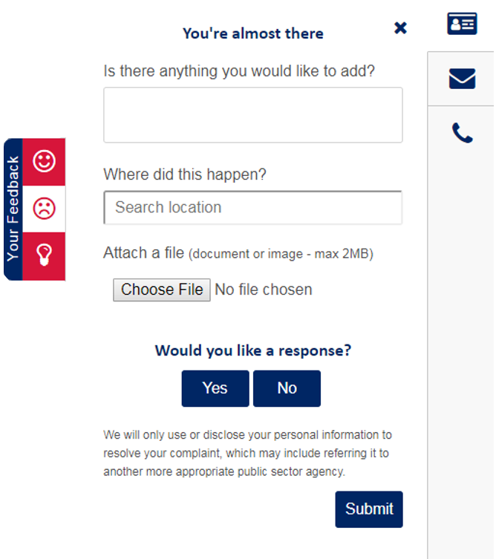

Location is an optional field. If you are using this field, the default is: Where did this happen? If you choose to customise the question, it
- needs to be phrased as a question;
- cannot be much longer that what is displayed as the default;
- needs to be relevant for both Compliments & Complaints

If a customer submits feedback and requests a response, Feedback Assist will send an automatically generated email advising the customer we have received their feedback.
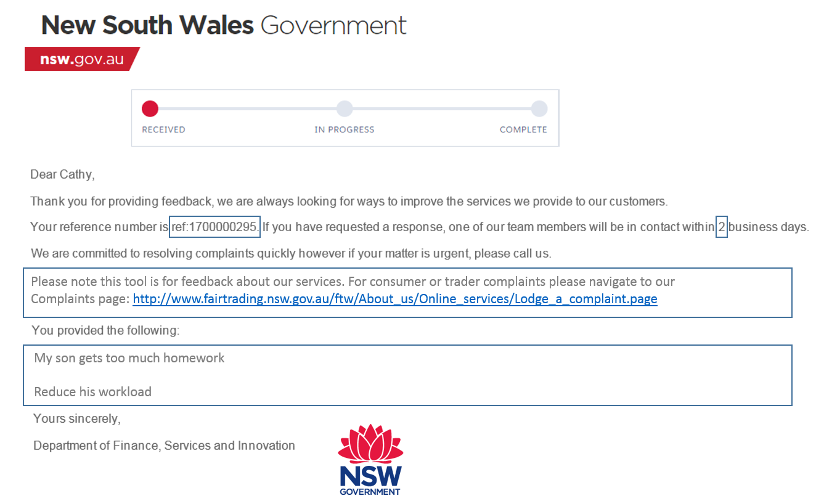
Will display anything the customer has input on all 3 questions
Optional additional paragraph.
Reference # - unique number for each case
SLA – number of business days you will commit to contacting the customer (acknowledge)
This email is not considered to be the acknowledgment of the feedback – this happens when a person has accepted the case and communicates with the customer.

What are Knowledge Articles?
Knowledge Articles can be used in the widget to provide the customer with a suggestion that might assist them with their feedback. Knowledge Articles will appear as hyperlinks under the heading “Suggested Articles” on the first page of the widget. Every suggested article is linked to one specific webpage.

How do Knowledge Articles work?
When a customer types a keyword (in this case, “homework”) and the suggested article will display at the bottom of the first page of the widget. In this scenario, the article is titled “Homework Policy”. If the customer clicks on this link, they will be taken to the relevant webpage.

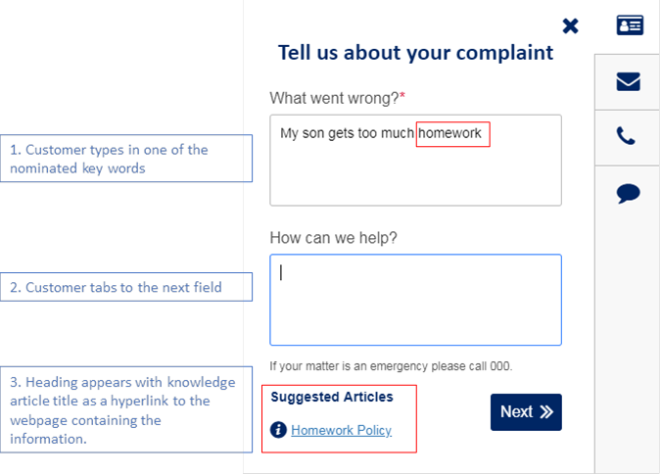

How do I setup Knowledge Articles?
If an agency would like to use Knowledge Articles, please get them to send an email to support@onegov.nsw.gov.au with the following information:
- Their Agency name;
- The title of the Knowledge Article e.g. “Application Forms”, “Homework Policy” etc.
- The URL link for the article;
- The recommended keywords they want to trigger the article e.g. “Form”, “Homework” etc.

